Odd Space

Game Design Document

Chaotic Evil

Òscar Canales, Raul Cano, Denis Deconinck, Carles Garriga, Alex Gesti, Pol Pallarés

**Índex**

**Game Pillars** **4**

**Narrative Structure** **5**

Story 5

Introduction 5

Chapter 1 5

Chapter 2 6

**Controls** **8**

**Gameplay Features** **10**

Top-Down Tile maps 10

Animated Cutscenes 10

Combat 10

Random and Scripted Encounters 10

Basic AI 10

Different worlds to explore 10

Ship features 10

Bar features 11

Dungeons 11

Bestiary 11

Friendly UI 11

**Maps and Buildings** **12**

Fancy Ship 12

Scene 1 - Fancy Ship - Kitchen 12

Scene 2 - Fancy Ship: Ship’s main deck 12

Rusty Ship 13

Scene 3.1 - Rusty Ship: Entrance 13

Scene 3.2 - Rusty Ship: Command Room 13

Cantina 14

Scene 4 - Cantina: Fuel Station 14

Scene 5 - Cantina: Inside 14

General Map 15

Scene 6 - General Map 15

Dungeon 16

Scene 7 - Dungeon Entrance 16

Scene 8.1 - Dungeon: Level 1 16

Scene 8.2 - Dungeon: Level 2 17

**Units** **17**

Team members description 18

Main character 18

The Old Captain 18

Stats 18

Special Abilities 19

Protagonist 19

Old Captain 19

Actions 19

**AI** **19**

Enemy description 20

Enemy stats 20

Enemy abilities 21

Mutant rat 21

Giant bat 21

Drunk customer 21

Captain Rat-Eye 22

**Item stats** **23**

Weapons 23

Consumable items 23

**Quests and puzzles solved** **24**

Quick guide before reading the maps 24

Scene 0 - Tutorial battle 24

Scene 1 - Fancy Ship: Kitchen 24

Scene 2 - Fancy Ship: Ship’s main deck 25

Scene 3.1 - Rusty Ship: Entrance 26

Scene 3.2 - Rusty Ship: Command Room 26

Scene 4 - Cantina: Fuel Station 27

Scene 5 - Cantina: Inside 27

Scene 6 - General Map 28

Scene 7 - Dungeon: Entrance 28

Scene 8.1 - Dungeon: Level 1 29

Scene 8.2 - Dungeon: Level 2 29

# Game Pillars

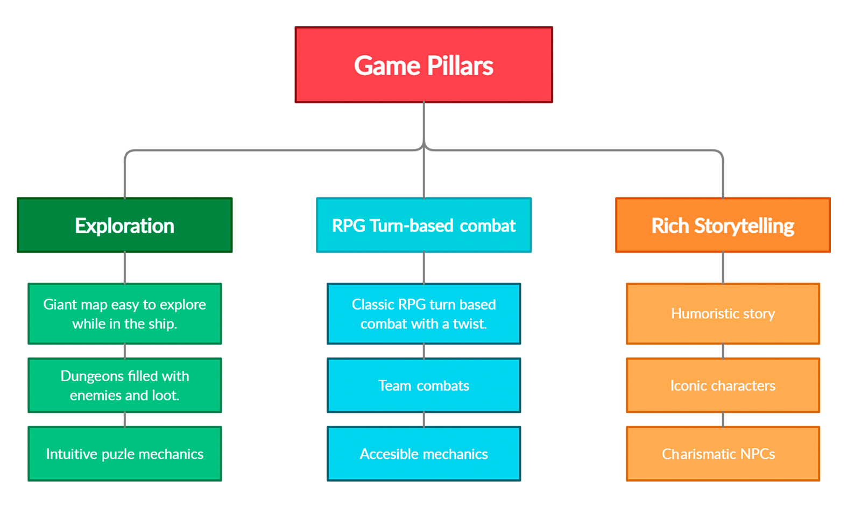

*Diagram of the game pillars that we base our project on, with three characteristics of each one.*

# Narrative Structure

## Story

### Introduction

Long ago, humanity's research on space traveling advanced to the point where societies developed in different planets and even in the middle of space, space ships became the main mean of transport and our story begins in one of the largest of them.

Our main character is daydreaming about his desired space pirate life, he sees himself as someone super powerful and strong, taking down every single enemy in one go with his crew, this part serves as combat tutorial, after taking down several enemies and our main character is about to make his last action the dream ends and we see the real scene where our main character is cleaning dishes at a very large kitchen.

He is nowhere close to his real image as he is a young man, unathletic and lazy, he's actually one of the newer members of the crew so the worst tasks. While finishing cleaning up all the mess the crew left behind after dinner, the kitchen's Chef, a very charming middle aged man, refers to him as "pawn" while ordering him to finish up fast because the captain wants to see him.

The main character reunites with the ship's captain and after a few words he is ordered to clean up the exterior engines with a special suit, letting him stick to walls so it can be easier to clean them. While he is cleaning, the ship suddenly passes nearby an asteroid field. They do not put the ship in danger, but none of the crew members seem to remember that the main character is cleaning the engine's exteriors. Without realizing it, a rock crashes into the main character's boot, deactivating it, and the other one simply slips. He ends up floating in space, watching the ship go away in the distance.

Moments after this accident, the main character lands on something awfully hard and rusty, a few seconds pass until he realizes it's another ship, a very small, rusty and old ship, so he simply goes inside to investigate it for a while until he arrives at the cockpit where he encounters an old, short and angry captain who launches a beer bottle straight up to the face of the main character knocking him out in an instant.

### Chapter 1

After a long discussion with this captain, they arrive at a space gas station where they begin speaking with an old friend of the captain with 10 beers by his side, he then proposes to our team that they should reunite his legendary armor and weapons to restore his long lost crew.

The manager of the bar then offers to equip our team in exchange for some of the materials they bring back from their journey, but our captain is so drunk that he perceives the kitchen tools as weapons and armors, going to his ship equipped with a spatula and a pan.

After traveling for a while they arrive at a planet's dungeon, where the supposed "legendary sword" rests. In the dungeon, our team is encountered with various enemies until they arrive to a large room with the sheathed sword in the middle, our captain only takes the sheath, disposing of the sword calling it a useless piece of old metal.

Before leaving the room a giant rat comes out of nowhere with a scar in the eye, confusing our captain into thinking that the rat is some old pirate named "Rat-Eye" and our team takes on the giant rat. After several hits without damaging the creature, this one leaves the battlefield, surprising the team.

While they're about to enter the ship with their newly looted "treasure" our team encounters a poor looking girl trying to steal anything worth some coins from their ship, a combat initiates and this thief doesn't even come close to hitting either of the team's members with any skill. After some time, she breaks down in tears and surrenders, joining the team in exchange of practising combat skills and with the intention of stealing some treasures from them.

When the new team arrives at the regular gas station, the old captain and his drunk friend start arguing about the results of this adventure, not long after this starts they are already drinking together as if nothing happened talking about their new objective. Our main character and the new member are trading with the kitchen's manager as this one offers a job opportunity to the main character: taking out the drunk customers to earn some coins.

As he accepts the job our captain is about to leave without the team, screaming that if they want to live adventures with him they must work on the ship too.

### Chapter 2

As our captain begins to explain the team their new objective, the name of the main character's old captain comes across, then he reveals their objetive's location as they travel, arriving at a luxurious dock with elegant buildings and a huge number of big ships as well as people celebrating their newest victories.

Taking advantage of their small ship, our team hides behind the huge one, infiltrating inside without being seen. After some time, they arrive at the captain's room, while searching important treasures to steal our captain finds a "great battle armor" this ends up being a thong, instead of getting away they end up being caught. Before they begin fighting, the captain starts laughing at our team, criticizing the main character for choosing his comrades. After a series of attacks, the captain gives up as all the laughing is killing him and our team escapes "Victorious".

After arriving at the bar, the scene repeats as the old captain and his drunk friend start fighting again and end up drinking, this story ends with our team navigating the space once more as they live more bizarre adventures.

# Controls

Our game is optimized for both keyboard and gamepad. For this reason, we offer predefined controls for the game.

In the gamepad's case, we give the following set of buttons:

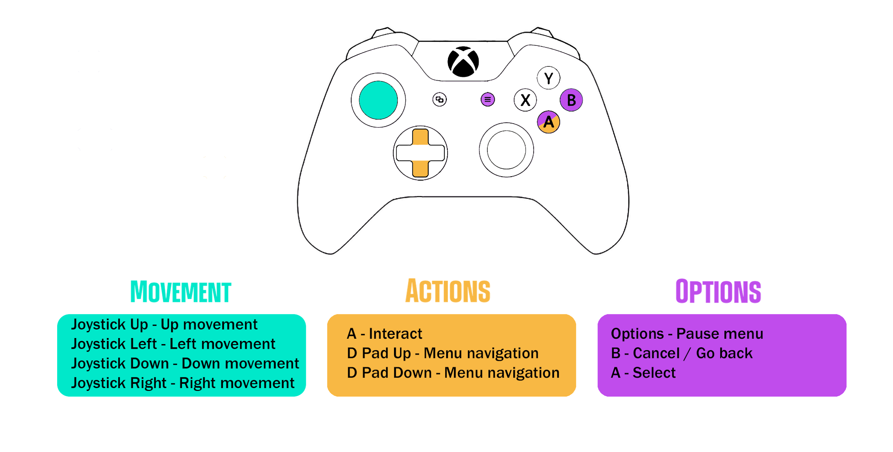

*Gamepad Controls*

For keyboard, we propose 2 different predefined sets of keys that you can choose between in the pause menu (the first one is selected by default). These presets are the following:

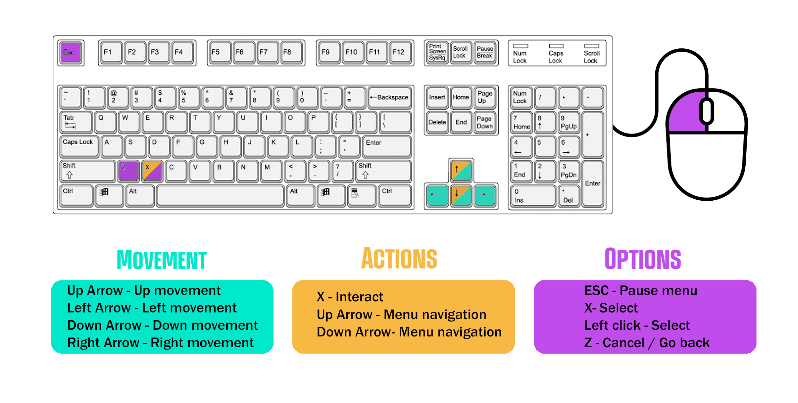

*Keyboard preset 1*

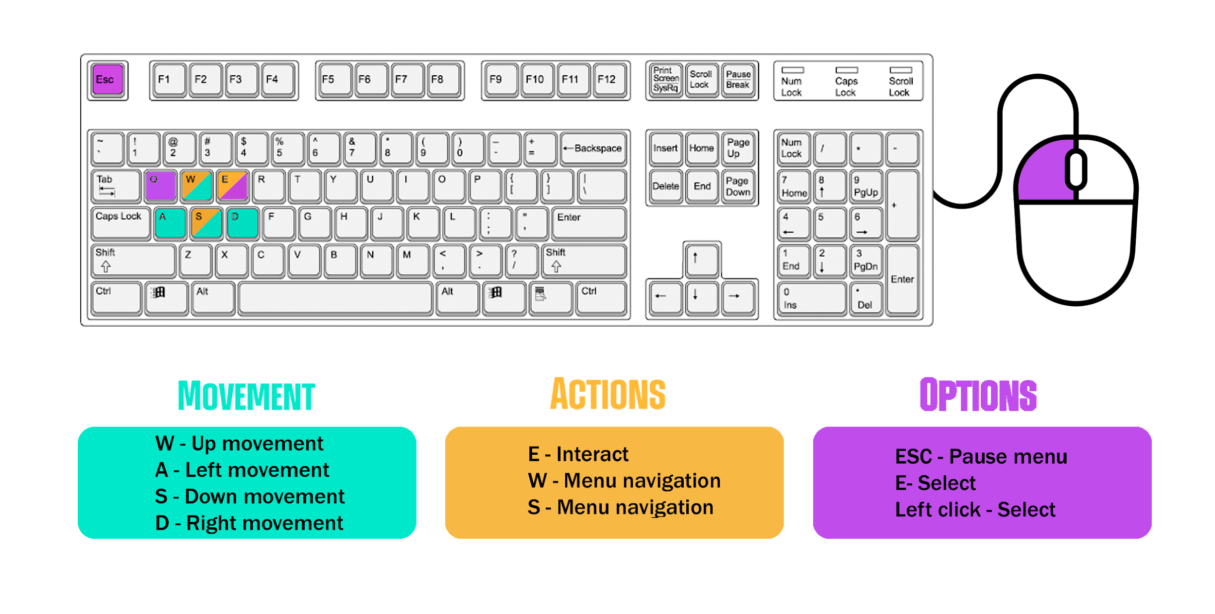

*Keyboard preset 2*

These controls can be fully modified by the player anytime if they don’t like them.

# Gameplay Features

## Top-Down Tile maps

The game is made with a Top-Down view in tile maps developed with the Tiled tool.

## Animated Cutscenes

To make this experience more cinematic there are some cutscenes through the game that will explain the narrative in a better way.

## Combat

The game features a classic RPG turn-based combat system, making your actions count.

Everyone has its own pace, keep track of your team members' speed and be careful with the agile monsters.

Stamina is needed to perform some special skills, remember to keep track of it since it can only be recovered with a few items.

## Random and Scripted Encounters

The game contains scripted battles, like the boss battles.

Other fights depend on random number generation and a probability of encounter.

## Basic AI

Because the most important gameplay feature of a RPG game is the combat, we have to develop an AI that can control the enemies in combat choosing their actions determined by the behaviour of the enemy it will attack or be more defensive, this is mainly used by the boss.

## Different worlds to explore

All the levels are connected within the same galaxy, so to move between them you will have to hop on your ship and travel through space to reach your destination.

## Ship features

Gigantic stellar map where you can travel around freely.

You can only land in your objective's area or the bar itself.

While in your ship, you may navigate around the menus and heal your team for the upcoming fights.

## Bar features

Here you can interact with various NPCs or talk to your teammates.

The first NPC is the drunk friend, he will give you quests and objectives.

On the other side there's The Innkeeper, he owns the place and will equip your team for the battles, both with new weapons and protection and healing related items in exchange for various materials.

You can also gather some fighting experience here fighting with countless irritating customers and sending them away for some rewards.

## Dungeons

Inside a dungeon you control the whole team as one.

If you stay too close to an enemy they may attack you, so be carefull.

Some chests may appear along your way for the ultimate treasure, be sure to check for some new items.

Every dungeon has its tricks, solve puzzles, defeat powerful foes or deactivate the traps to keep advancing.

## Bestiary

This game presents a bestiary feature where you can keep track of your enemies info at all times such as their defense parameters, attack values or their total health points as well as a list of skills they may use against you, making you more likely to succeed.

## Friendly UI

With the use of a friendly UI we want to ensure that the player enjoys the game without any usability or accessibility problems.

# Maps and Buildings

## Fancy Ship

First map of the game, where our protagonist starts in the kitchen doing his work like a kitchen boy.

This ship belongs to a famous pirate well known across the galaxy.

It is built with ebony wood and well decorated in the dining room and main living room, meanwhile the kitchen and maintenance parts are very poorly maintained and full of pipes, smoke and grease.

### Scene 1 - Fancy Ship - Kitchen

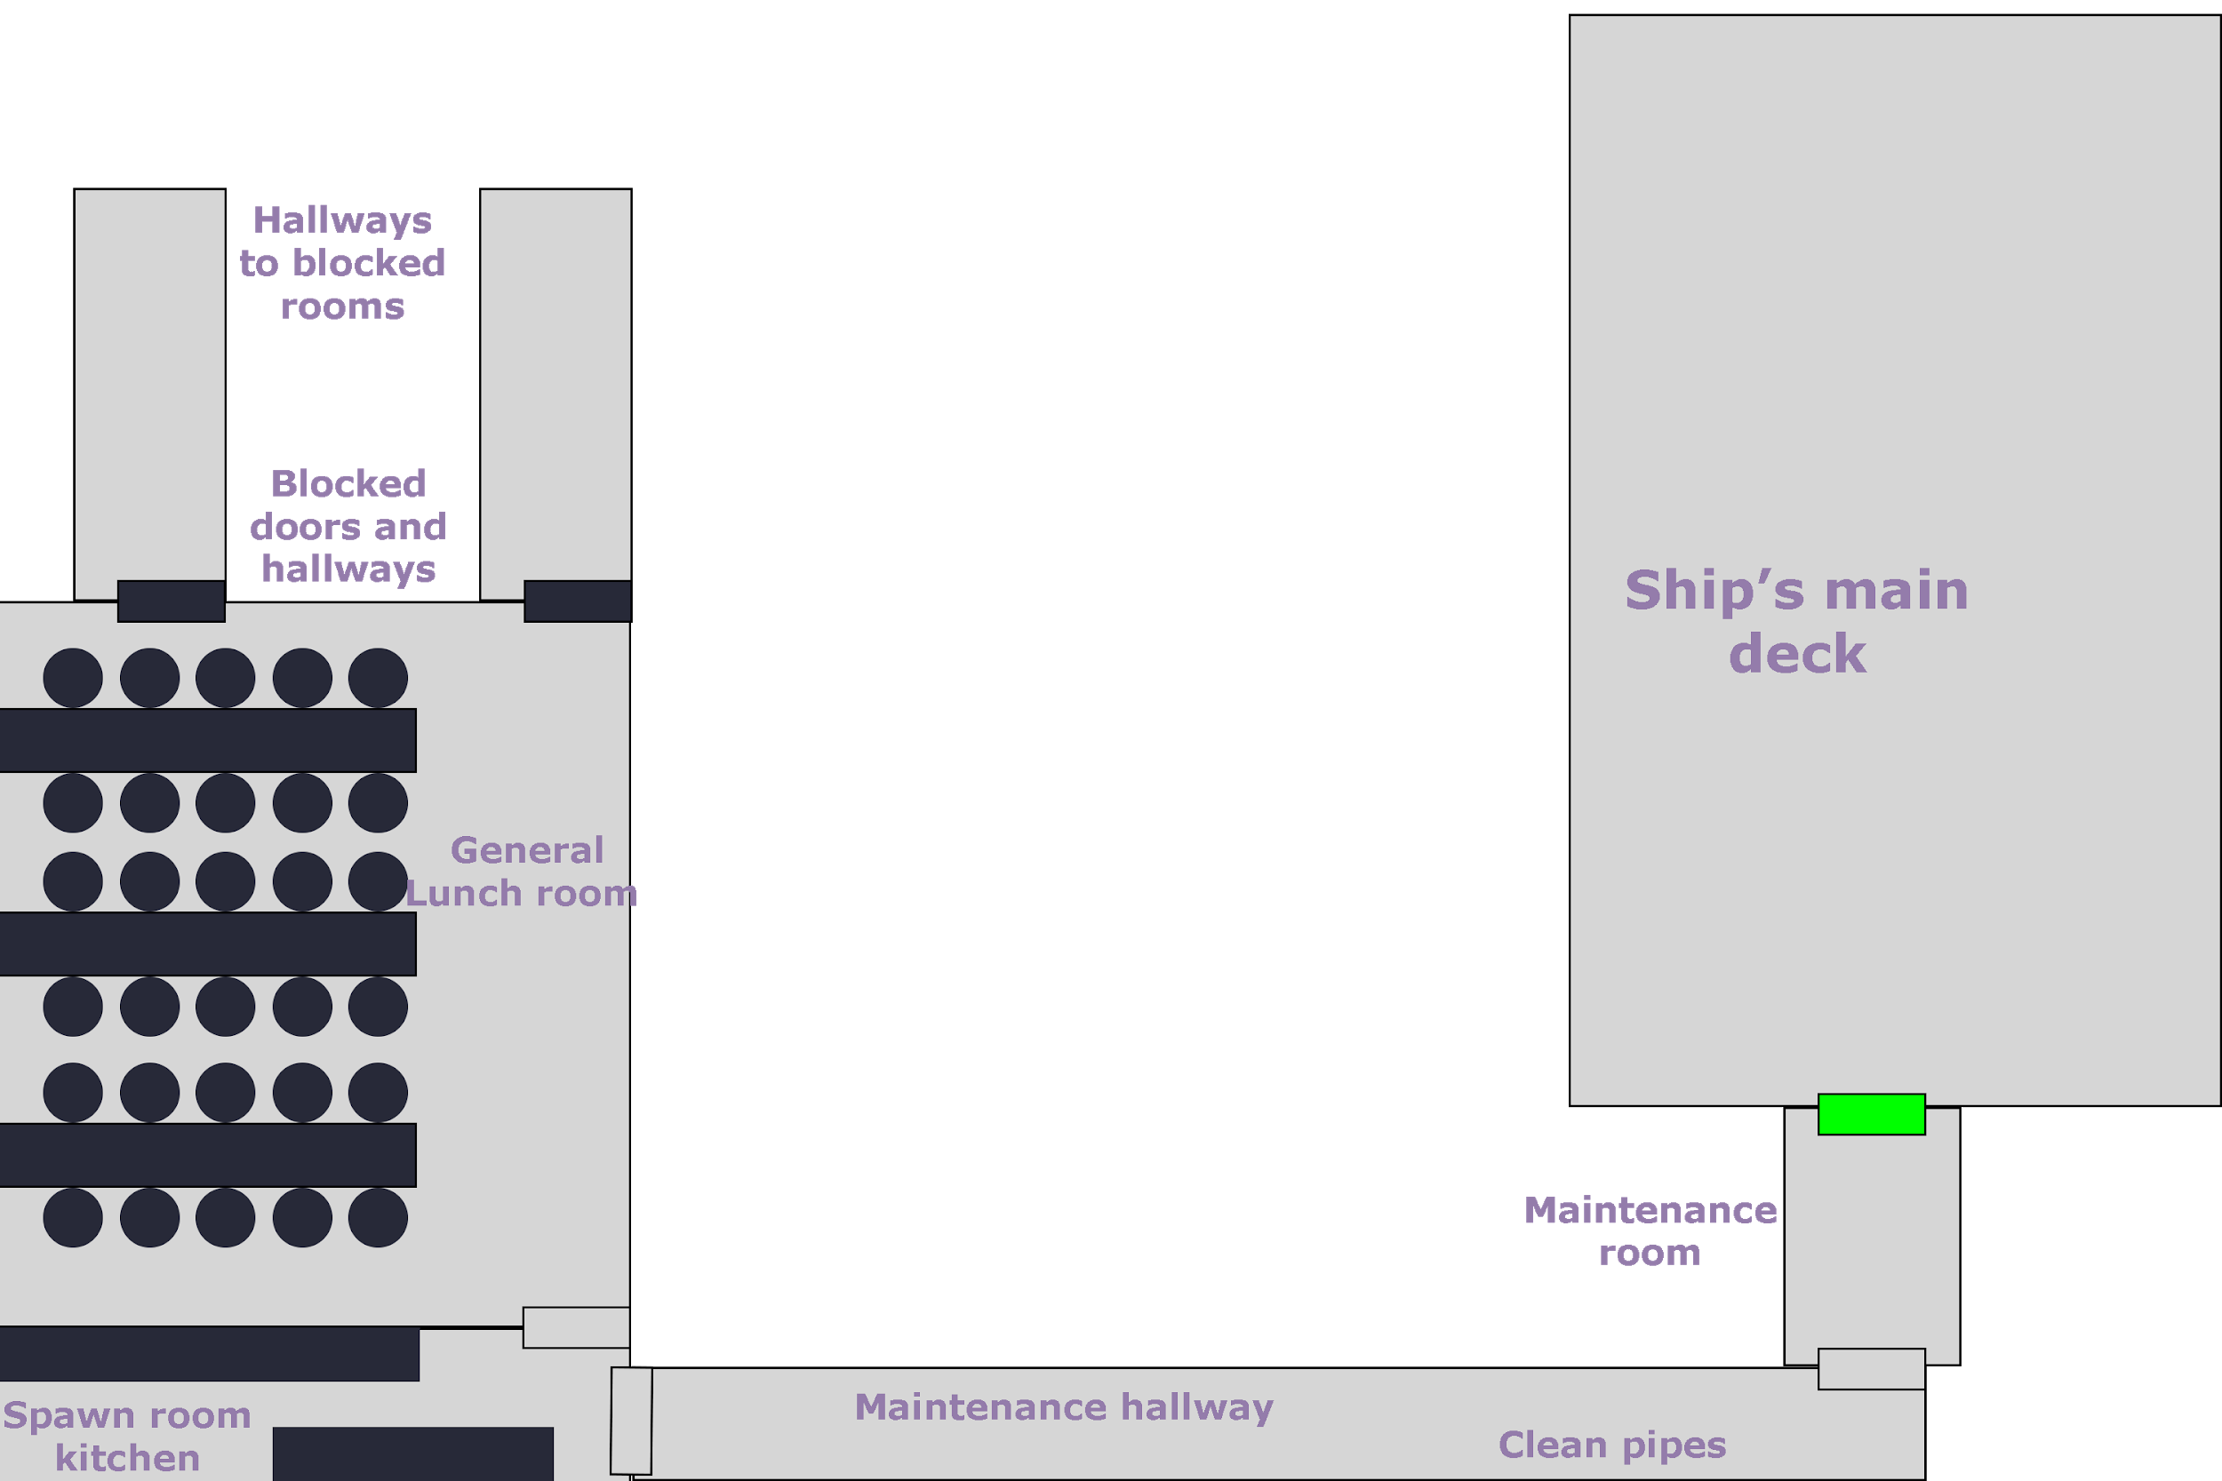

### Scene 2 - Fancy Ship: Ship’s main deck

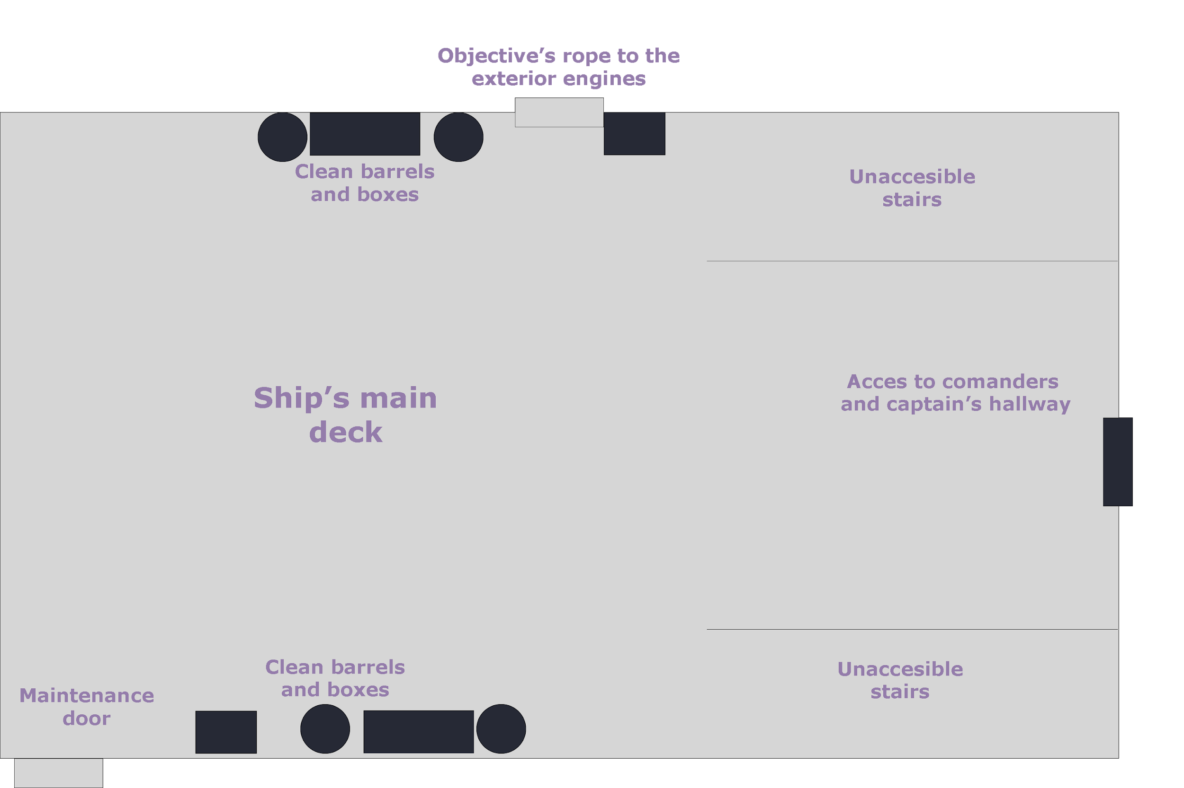

## Rusty Ship

Main ship and movement of the protagonist and his team.

This ship, although in poor condition, is a reliable old piece of machinery capable of moving through the galaxy with ease.

Despite its poor conditions, it has a good place to live and it turns out to be welcoming.

### Scene 3.1 - Rusty Ship: Entrance

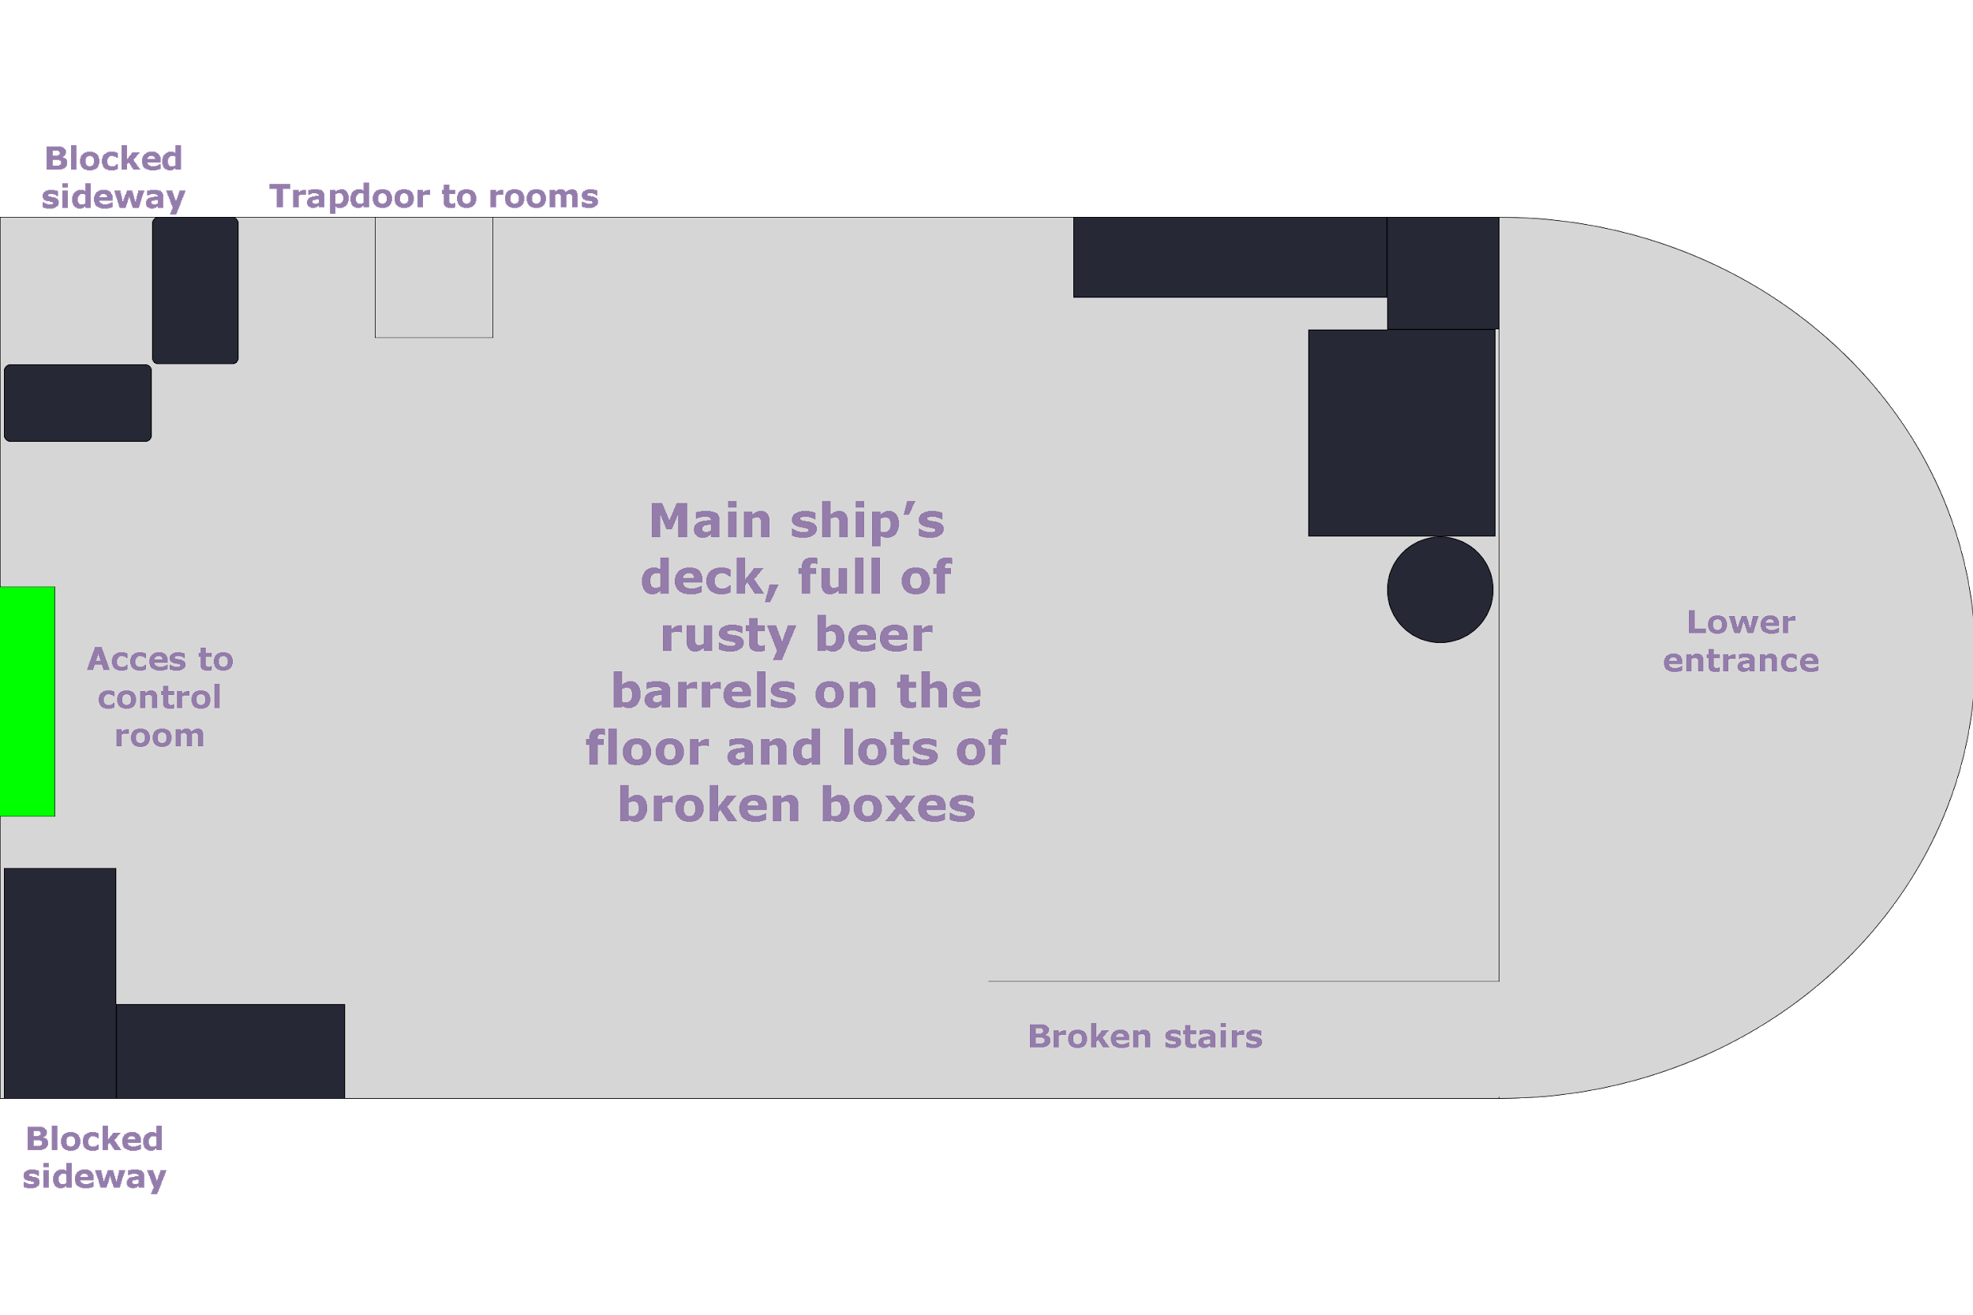

### Scene 3.2 - Rusty Ship: Command Room

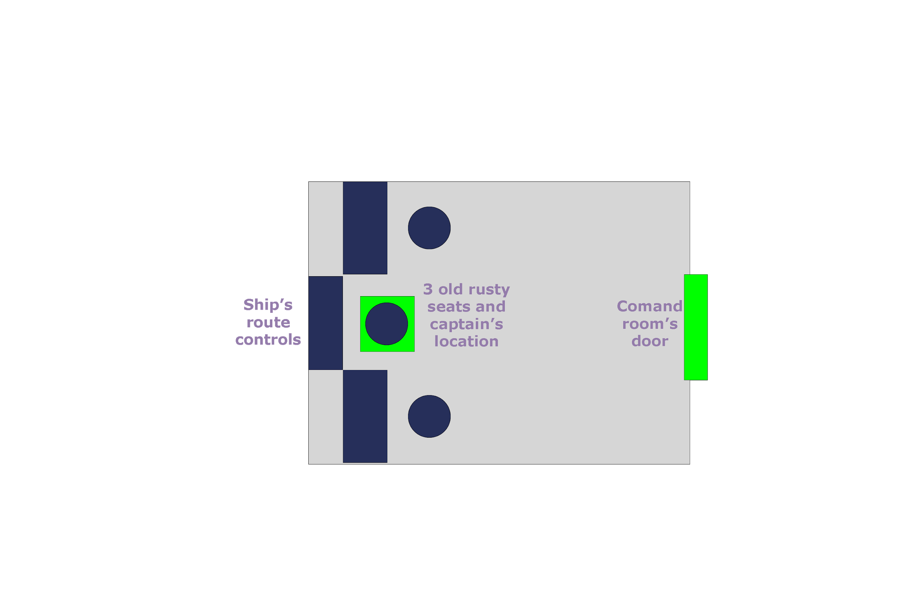

## Cantina

Place that will play the role of Town and main center of advancement of history.

In here, the player will be able to talk to different unimportant NPCs or buy items.

Here, the player can fight drunken NPCs who are not very friendly.

The player will receive missions from different characters within the Cantina.

### Scene 4 - Cantina: Fuel Station

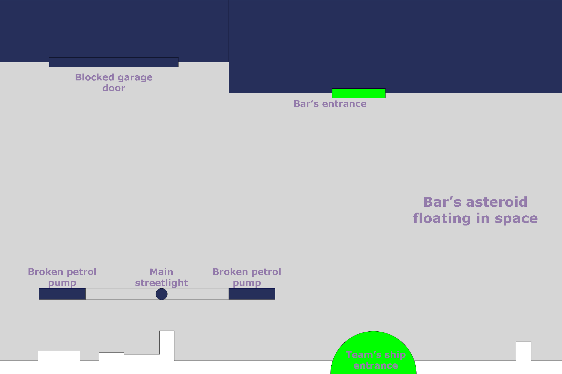

### Scene 5 - Cantina: Inside

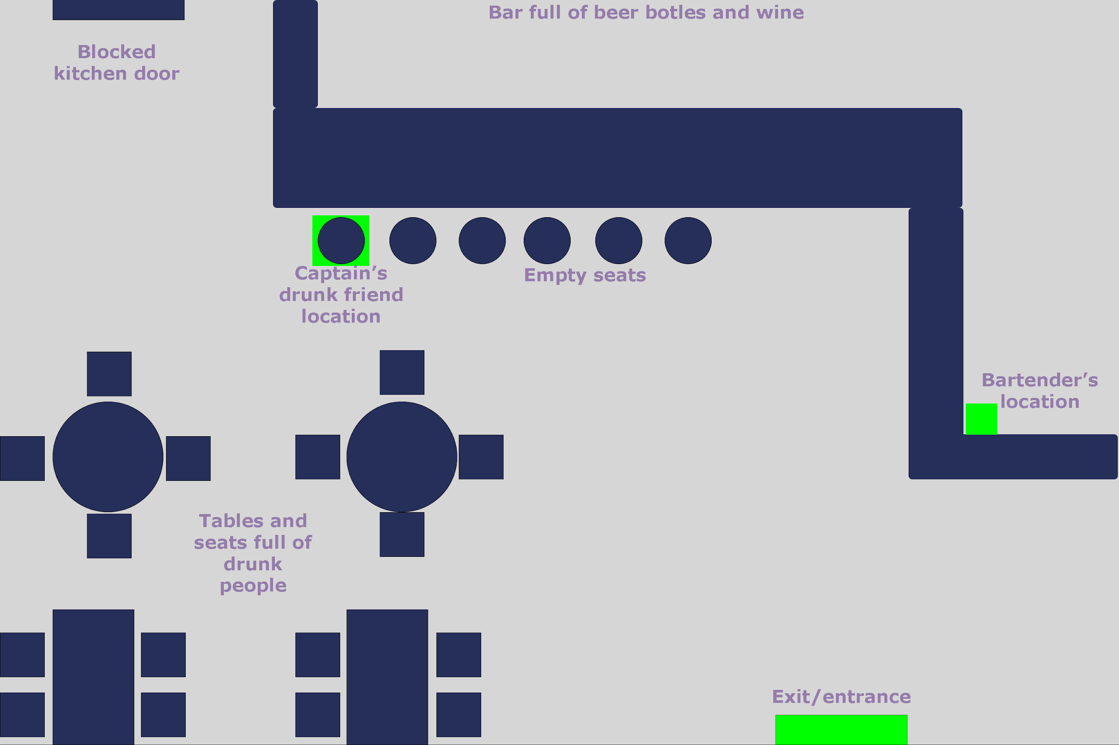

## General Map

The main map of the game, in which the player can move from one point to another.

This map, at the moment, only shows the places found by the captain, perhaps one day in one of his adventures they will come to find unknown places.

### Scene 6 - General Map

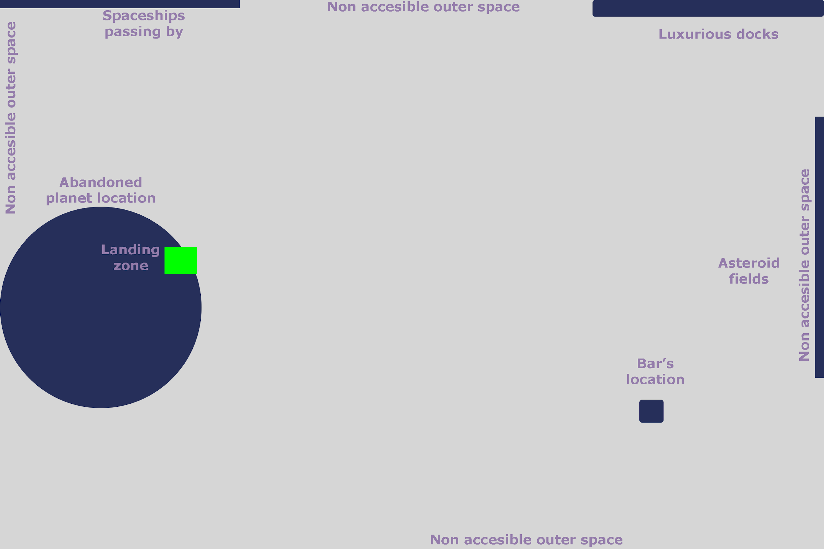

## Dungeon

First dungeon the player will find.

In this, the player must be observant to be able to solve the puzzles.

The player must be well equipped with enough potions to be able to defeat some hordes of enemies.

This dungeon will be a cave with some curious writings.

The particular creatures of this place are usually rats and bats, although the player may find some unexpected surprise at the bottom of this cave.

### Scene 7 - Dungeon Entrance

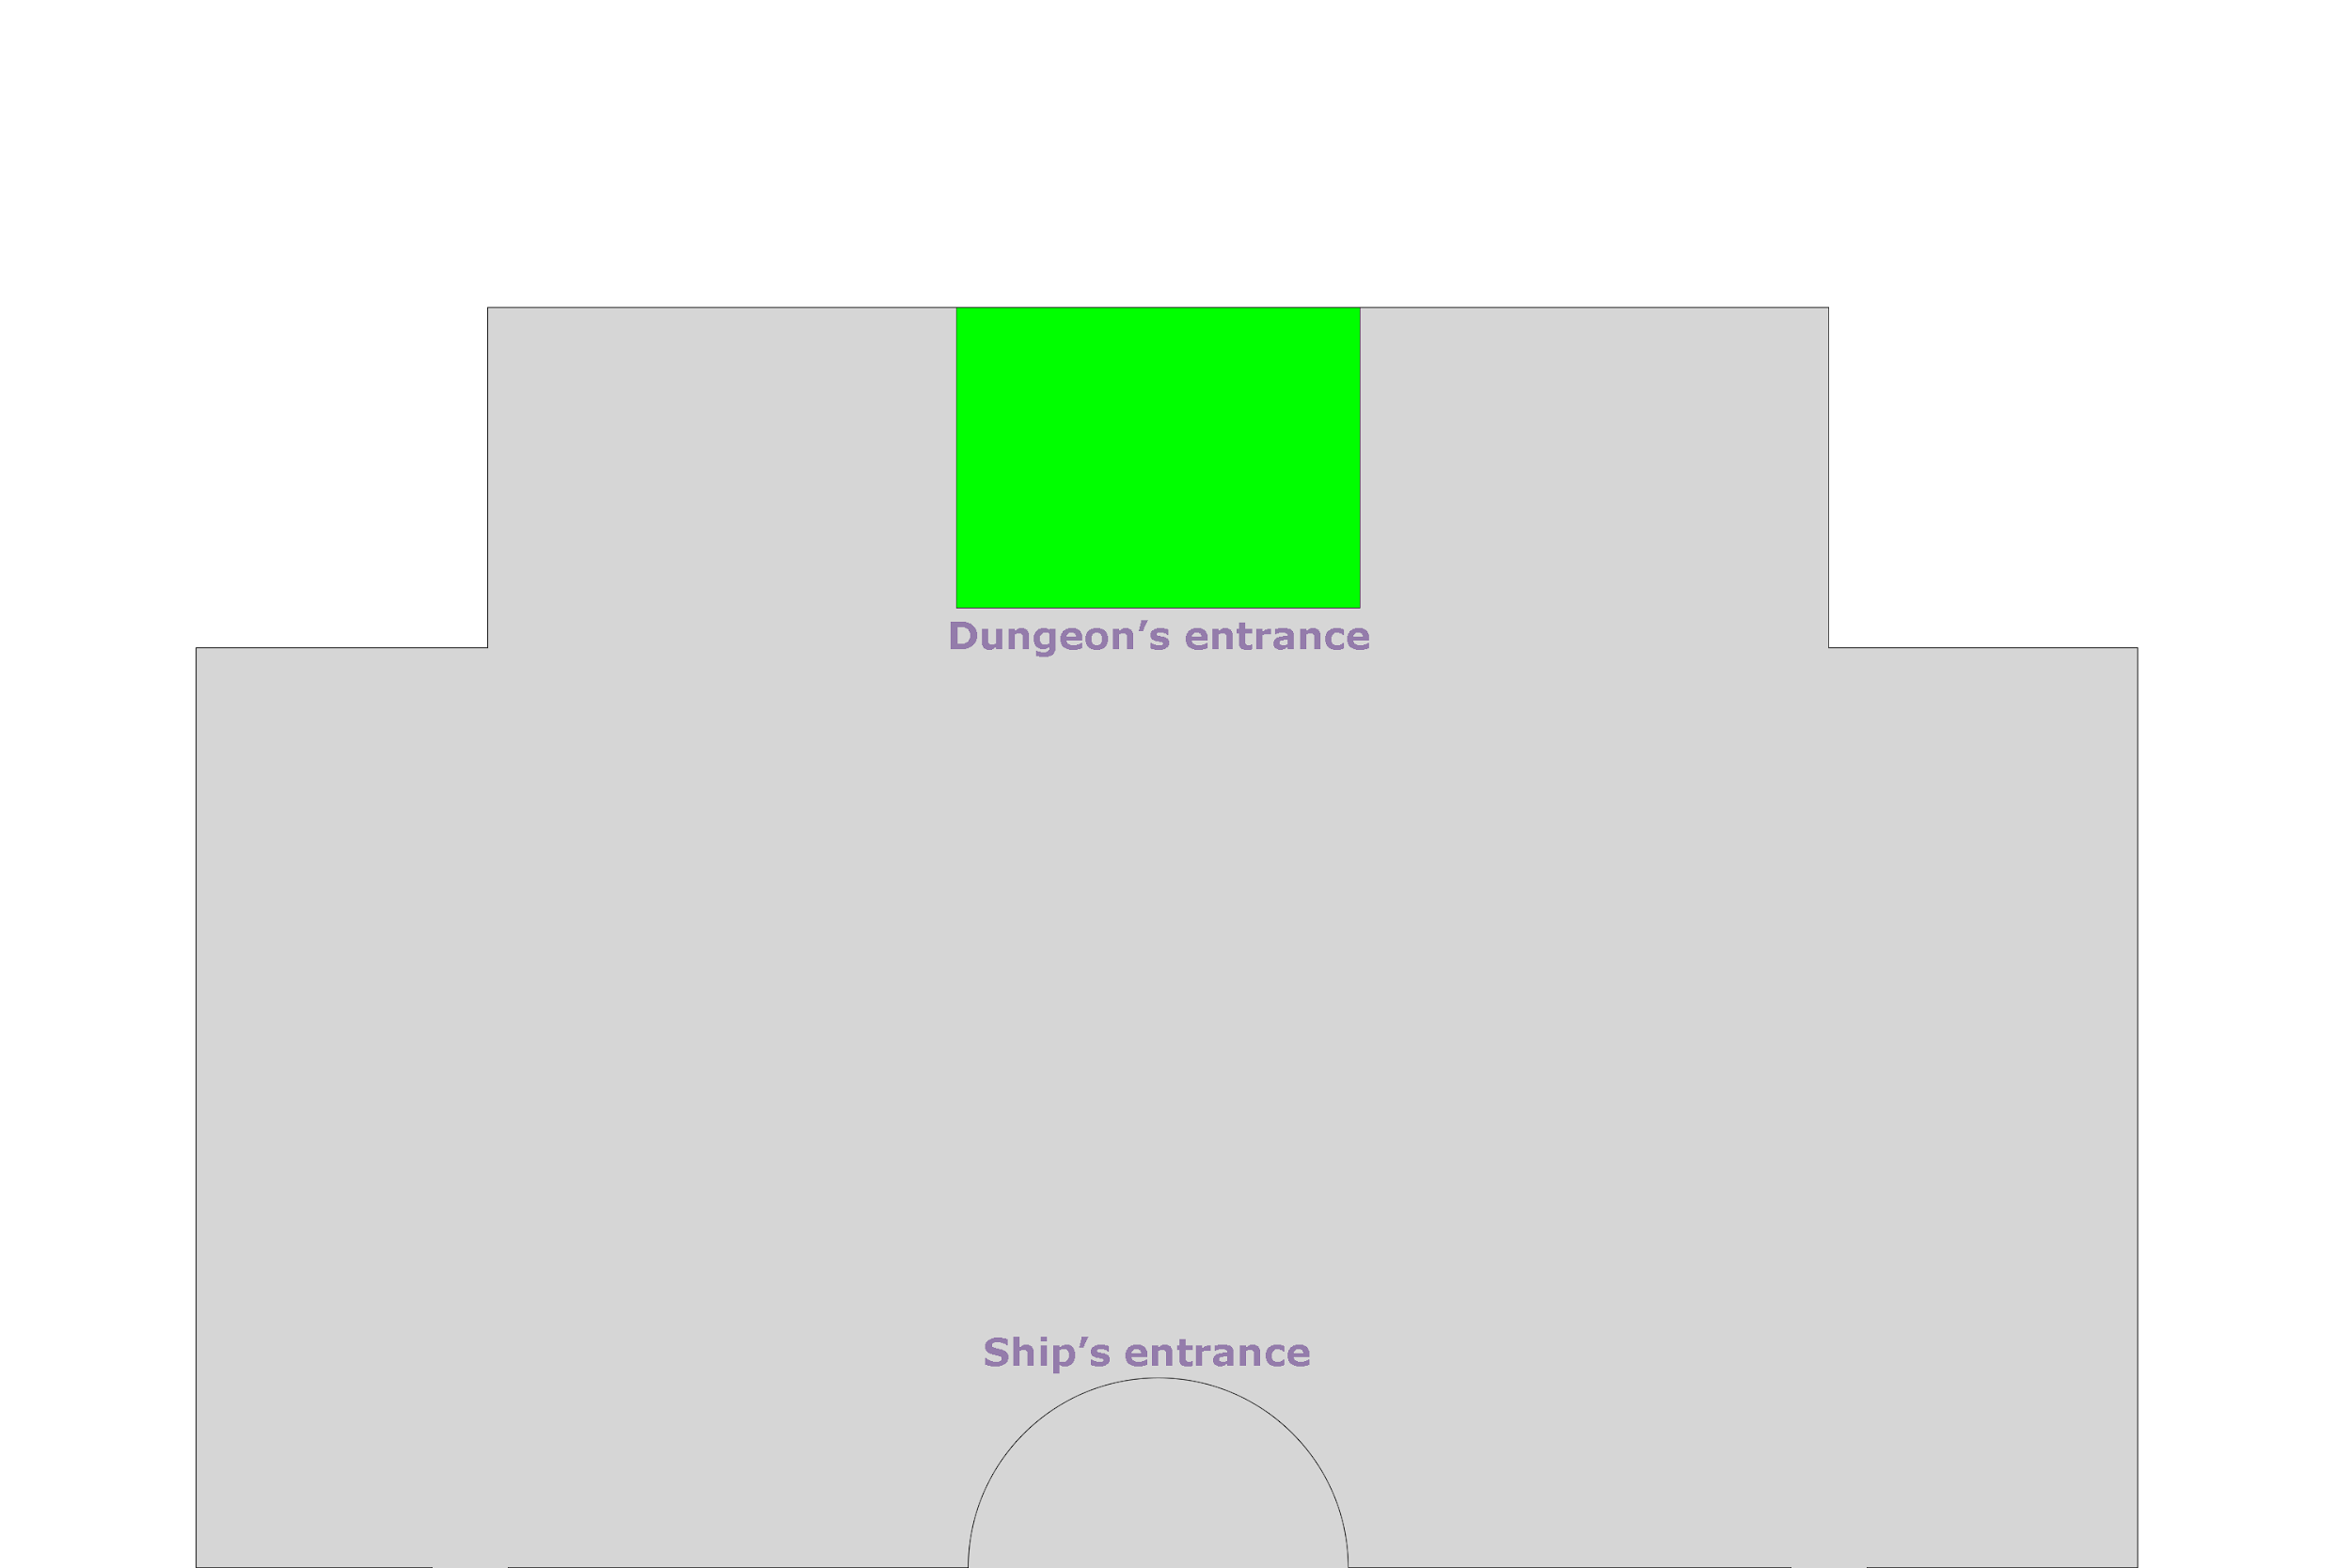

### Scene 8.1 - Dungeon: Level 1

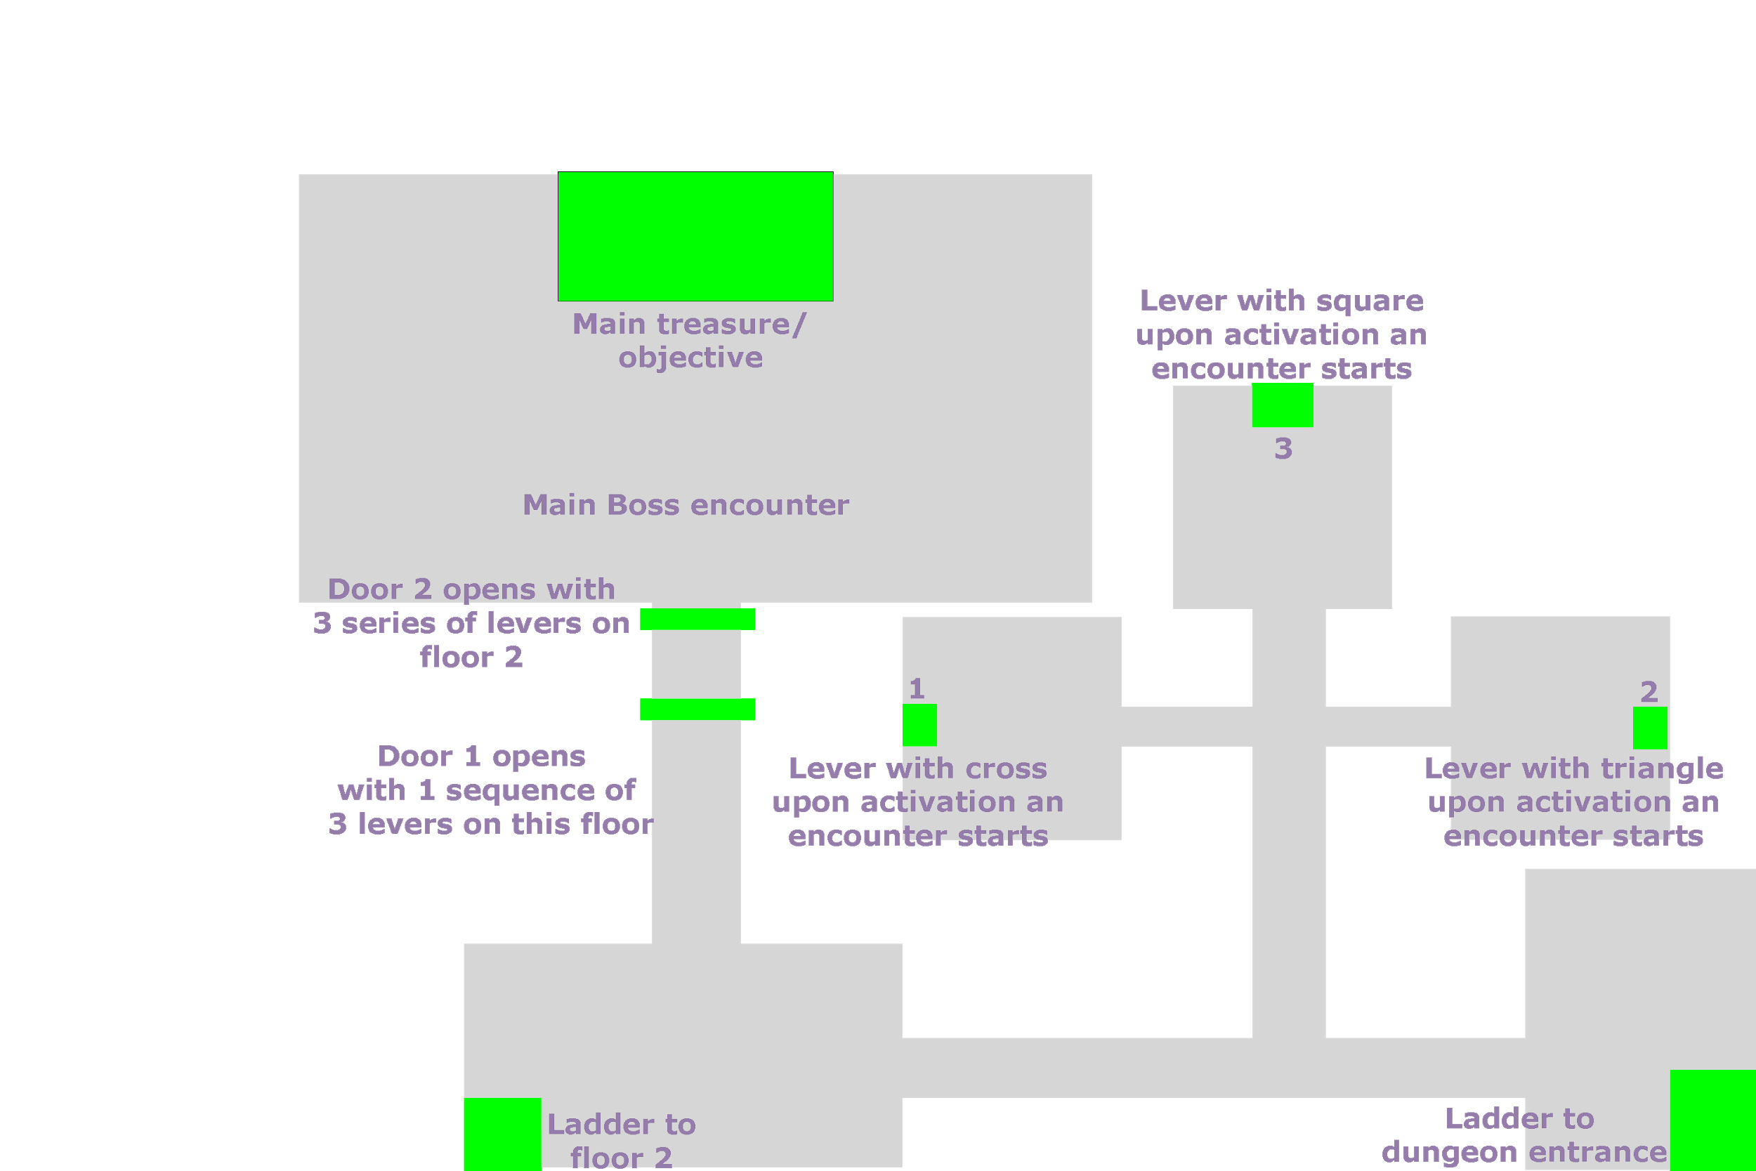

### Scene 8.2 - Dungeon: Level 2

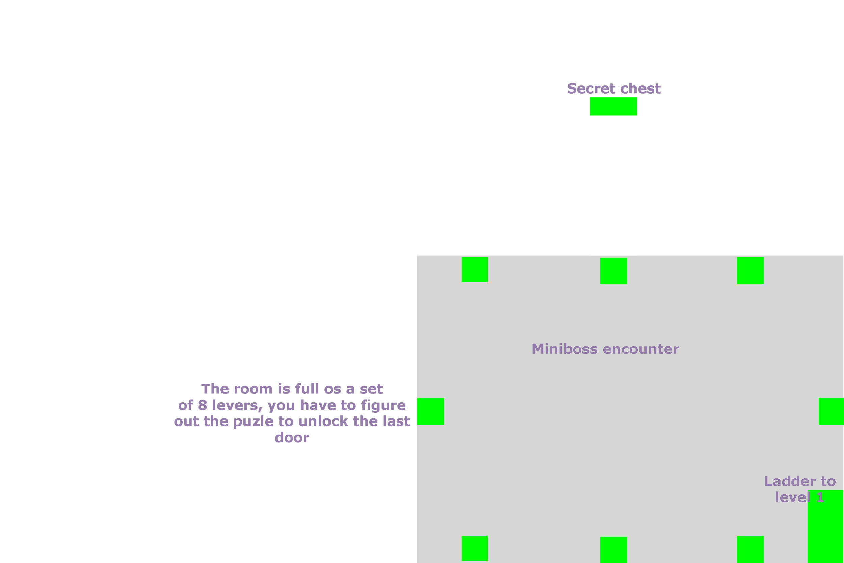

# Units

## Team members description

### Main character

Growing up in a problematic neighborhood where being assaulted was at the order of the day, our little adventurer had to train himself in the offensive martial arts to survive, after joining the pirates, he kept practising new moves to impress the ladies without any results to this day as he would always end up failing. He has great ambitions of his own but little to offer in a real combat situation.

Mainly focused on damage dealing and escaping death, he uses a set of variant light weapons known as "spatulas" for his attacks, over the years he has been practising his combat moves but he has never been in a battle of his own, he has created his own set of moves to deal major damage to a single target or a medium amount of damage affecting more than one target.

### The Old Captain

Several years have passed since this old captain stood foot in a battleground, his defensive traits let him stand his ground when it comes to receive damage and protecting his teammates, long ago he could have been in the largest crew among the galaxy but for now he mainly goes to the bar to drink with an old friend to talk about the long past glory days.

With a vast experience on the field, he can barely fight anymore so he focuses on supporting his teammates raising their spirits, his abilities consist on improving the team's overall stats such as ATK, DEF or SPL but he can also deal a medium amount of damage to single targets and inflicting debuffs to his enemies lowering their stats.

## Stats

|  |  |  |  |  |  |  |  |  |
| --- | --- | --- | --- | --- | --- | --- | --- | --- |
| **Character** | **Health (HP)** | **Special Points (SP)** | **Attack (ATK)** | **Defense (DEF)** | **Spell (SPL)** | **Speed (SPD)** | **Agility (AGL)** | **Luck (LCK)** |
| Protagonist | 15 | 10 | 6 | 3 | 5 | 7 | 8 | 2 |
| Old Captain | 20 | 16 | 3 | 6 | 5 | 3 | 2 | 1 |

## 

## Special Abilities

### Protagonist

|  |  |  |  |
| --- | --- | --- | --- |
| **Name** | **Description** | **Cost** | **Learn** |
| Lucky Slash | A standard slash with a boost to critical hit chance. | 2 SP | LV 2 |
| Spatula-boomerang | Area of effect damage dealing skill, deals light damage to all enemies. | 4 SP | LV 4 |
| Light recovery | The user heals himself for 10% of his max HP. | 3 SP | LV 4 |
| Steal | Heavy damage to a single target from afar with a chance to steal an item. | 8 SP | LV 7 |
| Triple spatula | Heavy damage to a maximum of 3 enemies but it deals damage to self. | 10 SP & -10% HP | LV 9 |

### Old Captain

|  |  |  |  |
| --- | --- | --- | --- |
| **Name** | **Description** | **Cost** | **Learn** |
| Crazy noise | Removes 1 DEF to one enemy. | 3 SP | LV 2 |
| Old scars | Deals medium damage 2 times to a single target. | 6 SP | LV 4 |
| Share a drink | Heals up to 30% HP to all teammates. | 5 SP | LV 4 |
| War cry | Adds +1 ATK & +1 SPD to all teammates. | 8 SP | LV 7 |
| Wake up | Revives a fallen ally with 25% HP. | 12 SP | LV 9 |

## 

## Actions

**Attack:** Slashes or strikes the enemy dealing a regular amount of damage with a chance of inflicting x2 damage.

**Guard:** In this turn you take a considerable less amount of damage.

**Skills:** Uses SP from the character to perform a selection of special actions.

**Items:** The player can choose to use up one item in the inventory.

**Run:** Chance to flee the battle, blocked in miniboss or boss battles.

# AI

## Enemy description

**Standard pirates:** these pirates are only seen in the main character's dream, they can be called **Dream Pirates:** They are very weak and can only use a basic slash.

**Mutant rat:** is quite sturdy and really restless. It usually attacks all the travelers it finds because it always wants to eat its cheese but they confuse the cheese with the smell of feet.

**Giant bat:** usually comes in pairs. It is always in the dark of the dungeon, trying to avoid all the sun they can. If you attack a bat, a wealthy man with a strange disguise may appear.

**Drunk customer:** can be found in the Cantine, the Innkeeper may offer rewards upon defeating them. Sometimes they start fighting with each other.

**Captain Rat-Eye:** the main boss of the first dungeon. It said that it was a human captain long time ago, but after arriving on the moon and trying to eat a piece of it, he transformed into a Captain Rat-Eye.

## Enemy stats

|  |  |  |  |  |  |  |  |  |
| --- | --- | --- | --- | --- | --- | --- | --- | --- |
| **Character** | **LV** | **Heal (HP)** | **Attack (ATK)** | **Defense (DEF)** | **Spell (SPL)** | **Speed (SPD)** | **Agility (AGL)** | **Luck (LCK)** |
| Standard pirates | 1 | 15 | 4 | 4 | 1 | 3 | 3 | 1 |
| Mutant rat | 3 | 45 | 30 | 12 | 3 | 18 | 21 | 9 |
| Giant bat | 4 | 60 | 20 | 24 | 40 | 32 | 16 | 12 |
| Drunk customer | 2 | 40 | 14 | 4 | 2 | 4 | 2 | 6 |
| Captain Rat-eye | 7 | 175 | 105 | 56 | 14 | 84 | 98 | 42 |

## Enemy abilities

### Mutant rat

|  |  |
| --- | --- |
| **Name** | **Description** |
| Enraged bite | It's the main attack. It consists of a bite to one team member to deal basic damage. |
| Tail whip | The mutant rat uses its tail as a whip to deal light damage to all team members. |

### Giant bat

|  |  |
| --- | --- |
| **Name** | **Description** |
| Screech | Screech lowering the DEF of all team members by 1. |
| Blood drain | Attacks one target with basic damage and can deal bled out. |

### Drunk customer

|  |  |
| --- | --- |
| **Name** | **Description** |
| Drink | Drinks from an infinite source of beer and heals up to 25% of HP or deal up to 25% of HP. |
| Alcohol rush | Charges into all team members dealing regular damage to all of them. |
| Secret bottle throwing technique | Throws up to 5 beer bottles to the team dealing light damage with each of them to a single target, then pays you for the wasted beer. |

### Captain Rat-Eye

|  |  |
| --- | --- |
| **Name** | **Description** |
| Summon the pack | Calls for help and summons up to 1 or 2 Mutant rats. |
| Intensive cheese eating | Spends 1 turn eating cheese to restore 15% of HP. |
| Hard bite | Deals heavy damage to one target, in the next turn it can't move as it's cleaning his teeth. |
| Body slam | Deals moderate damage to all his enemies. |
| Old special | Just before dying the Captain Rat-eye prepares a tornado tail whip hitting all creatures in the field with heavy damage. |

# Item stats

These are the items that you can find and/or buy in your adventure.

## Weapons

|  |  |  |
| --- | --- | --- |
| **Name** | **Description** | **Stats** |
| Rusty spatula | An old rusty spatula used to scratch the grease out of the oven. | + 1 ATK |
| Standard spatula | A not so used spatula, it still smells like new. | + 3 ATK / + 2 SPL / + 2 AGL |
| Silver spatula | A new powerful spatula, only used by the senior chefs in the galaxy. | + 5 ATK / + 4 SPL / + 4 AGL / + 2 DEF |
| Rusty pan | An old sticky pan very worn out from frying fish. | + 1 DEF |
| Standard pan | This pan is only used for standard meat. | + 3 DEF / + 2 ATK / + 2 SPL |
| Silver pan | A new powerful pan, this one is only used to elaborate the most select meat in the galaxy. | + 5 DEF / + 4 ATK / + 4 SPL / + 2 LCK |

## Consumable items

|  |  |  |
| --- | --- | --- |
| **Name** | **Description** | **What it does** |
| Raw meat | A small piece of raw meat. | + 25% HP |
| Large raw meat | A large piece of raw meat. | + 50% HP |
| Cooked plate | Some well cooked buffalo meat. | + 25% HP all team |
| Elaborated plate | A nice plate of buffalo meat with roquefort cheese to boost the flavor. | + 50% HP all team |
| 500ml beer | A nice bottle of standard beer. | + 25% SP |
| 1L beer | A nice bottle of standard beer. | + 50% SP |
| Ultra strong ron | The strongest ron one could find, strong enough to revive the dead. | Revives a fallen ally & + 50% HP |

# Quests and puzzles solved

## Quick guide before reading the maps

Objects marked in blue block the player's way

Objects in red represent the expected route to complete the scene

Objects in white represent optional routes, usually leading to a secret room or chest

Objects in green mark interactable objects, be it doors, levers or chests

## Scene 0 - Tutorial battle

First of all, you will be introduced to an unrealistic battle to teach you the ropes of the UI menus and how the battles work, this battle will be held in a massive deck later seen in the Fancy Ship.



## Scene 1 - Fancy Ship: Kitchen

In this scene, the player appears in the "Spawn room kitchen" at the bottom left of the screen, after a dialog with the chef he is sent to clean the outer engines with a special suit, here you have complete control of the character's movement and you can go to the "general lunch room" but the objective is to go to the "Maintenance room" located at the right of the scene accessible through the small "maintenance hallway" sorting some of the pipes in the way.

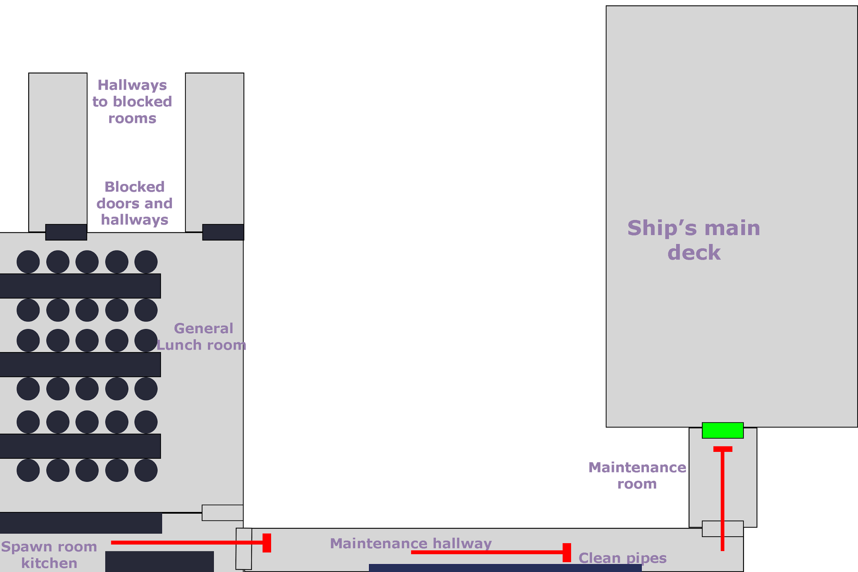

## Scene 2 - Fancy Ship: Ship’s main deck

In this scene, the player must move from the bottom left to the upper middle of the scene with the special suit ready to go clean the outer engines tied up in a rope, some barrels and accessible stairs decorate the scenery.

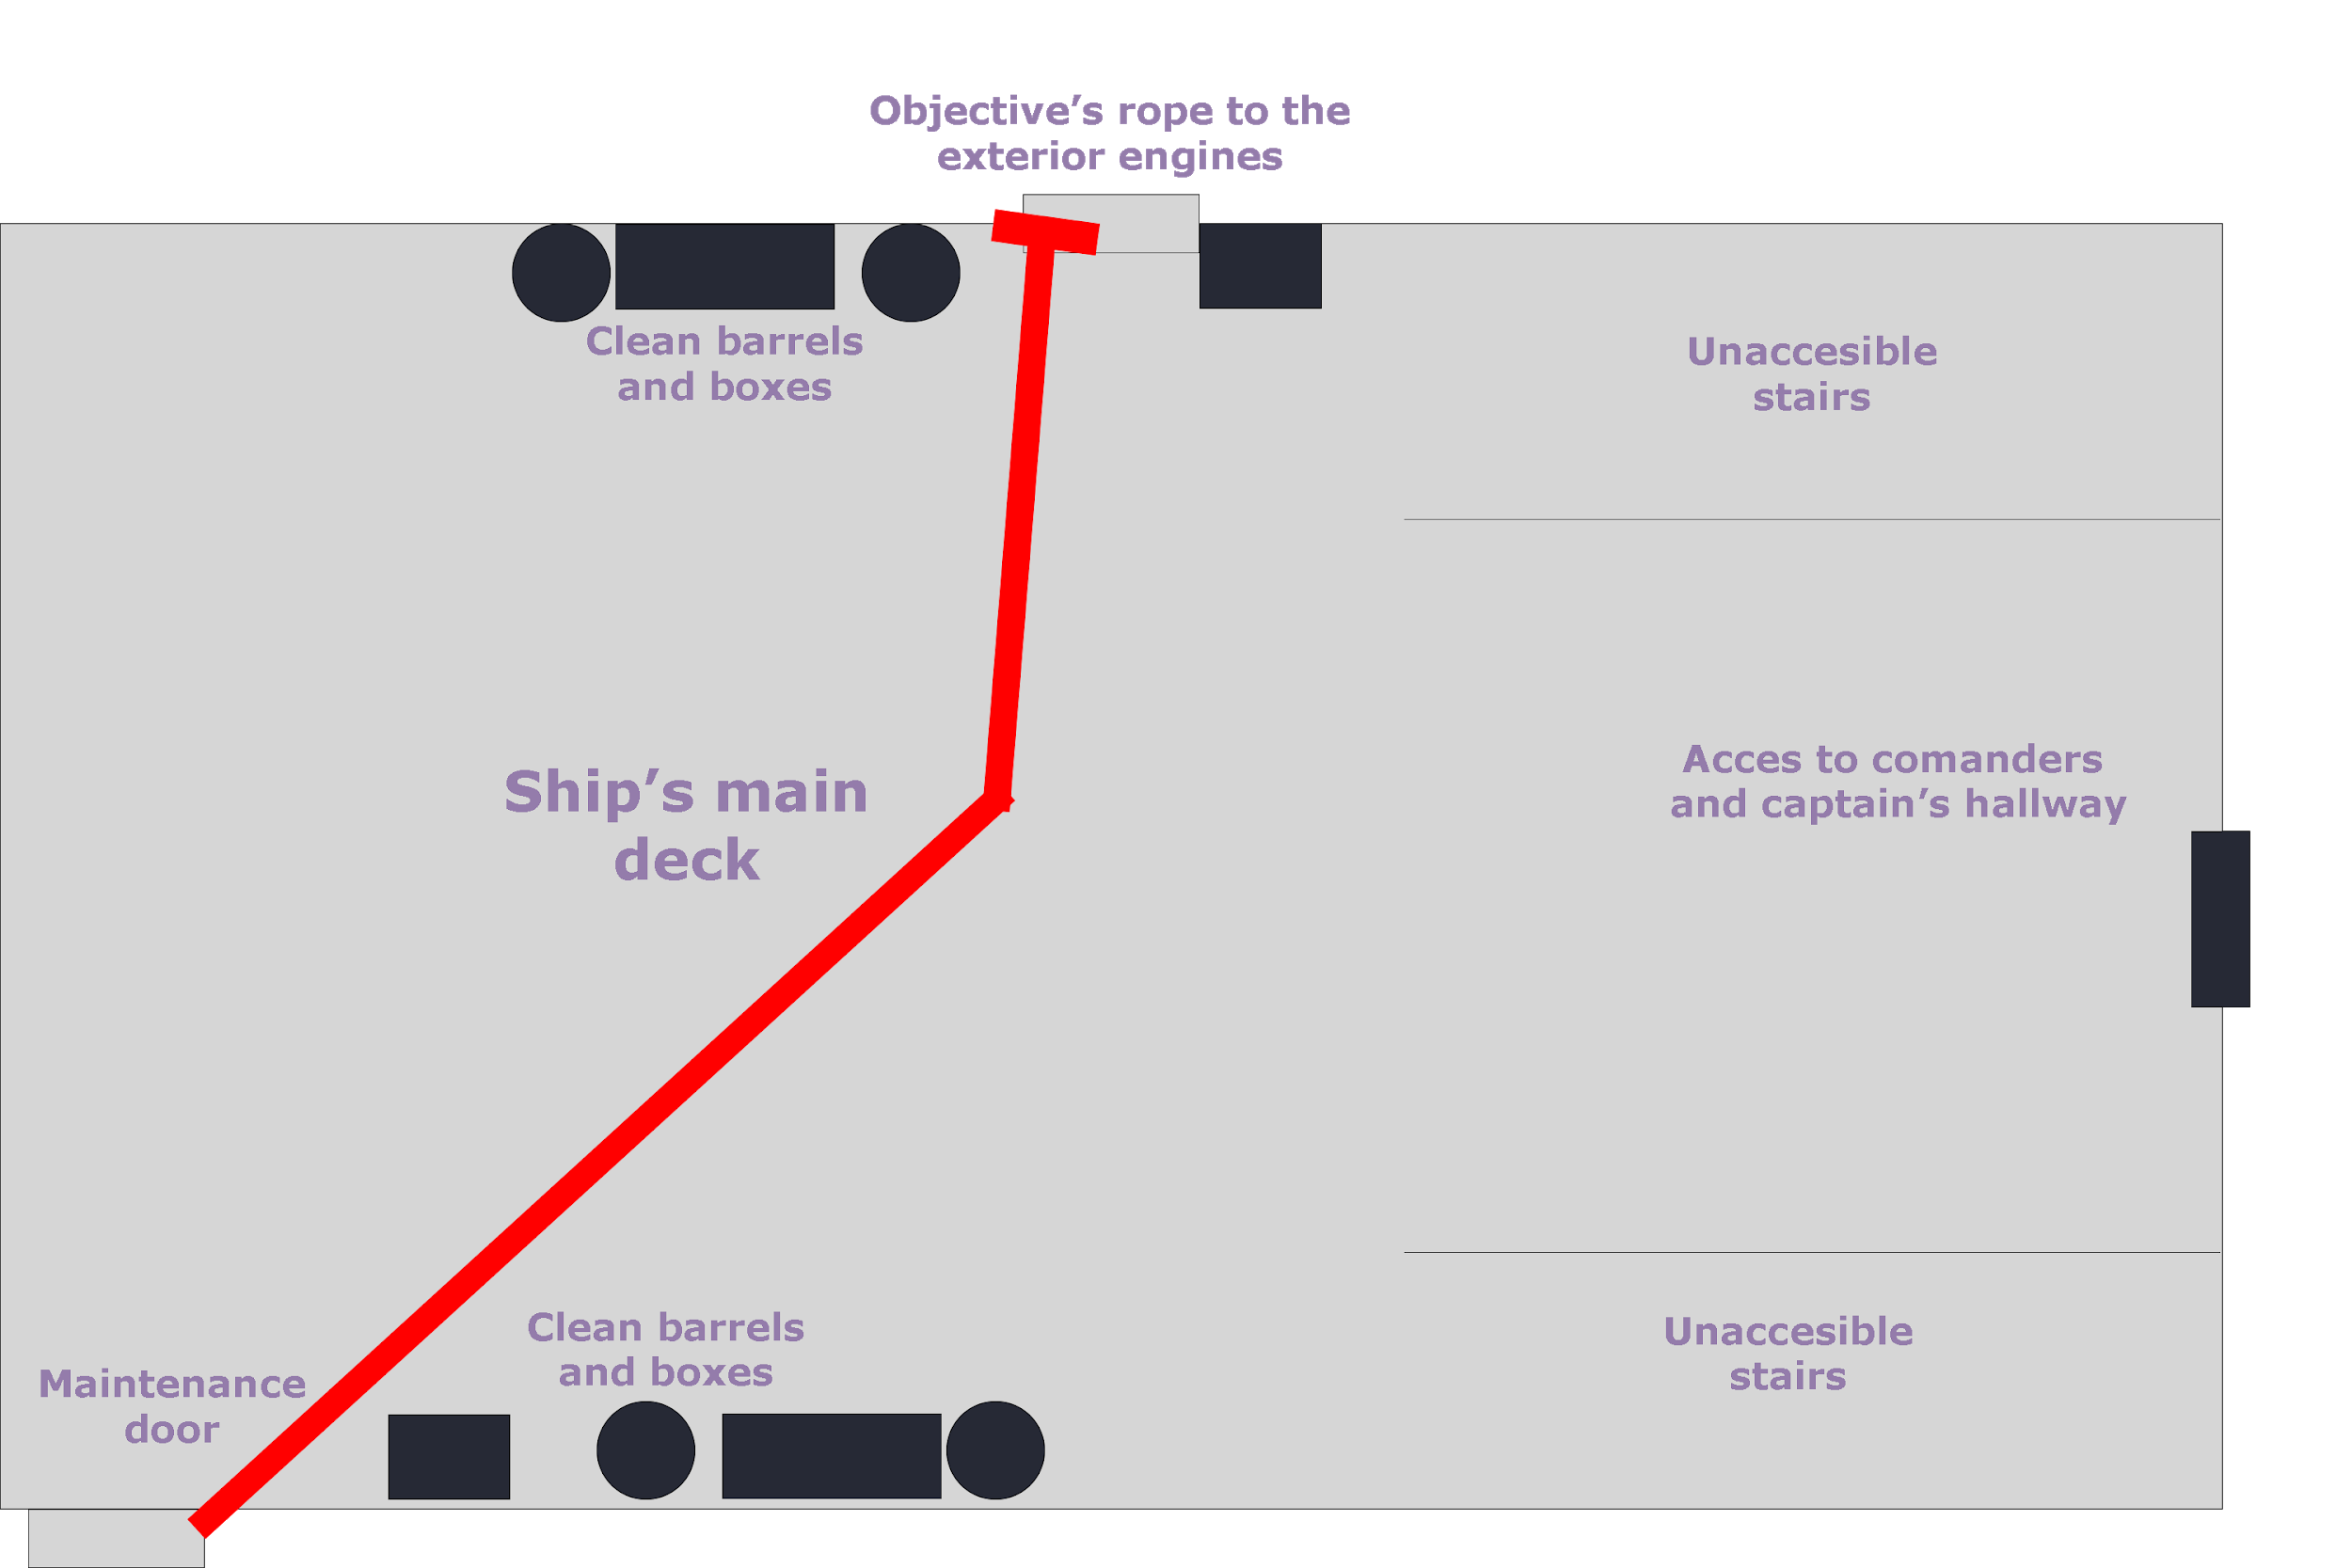

## Scene 3.1 - Rusty Ship: Entrance

Next up, the player finds himself on board of a small, old, rusty ship, appearing from the upper middle region of the scene the player must go to the "Access to control room", some broken stairs as well as beer barrels and broken boxes block the player from going to other regions of the ship. There's also a closed trapdoor which leads to the ship's rooms.

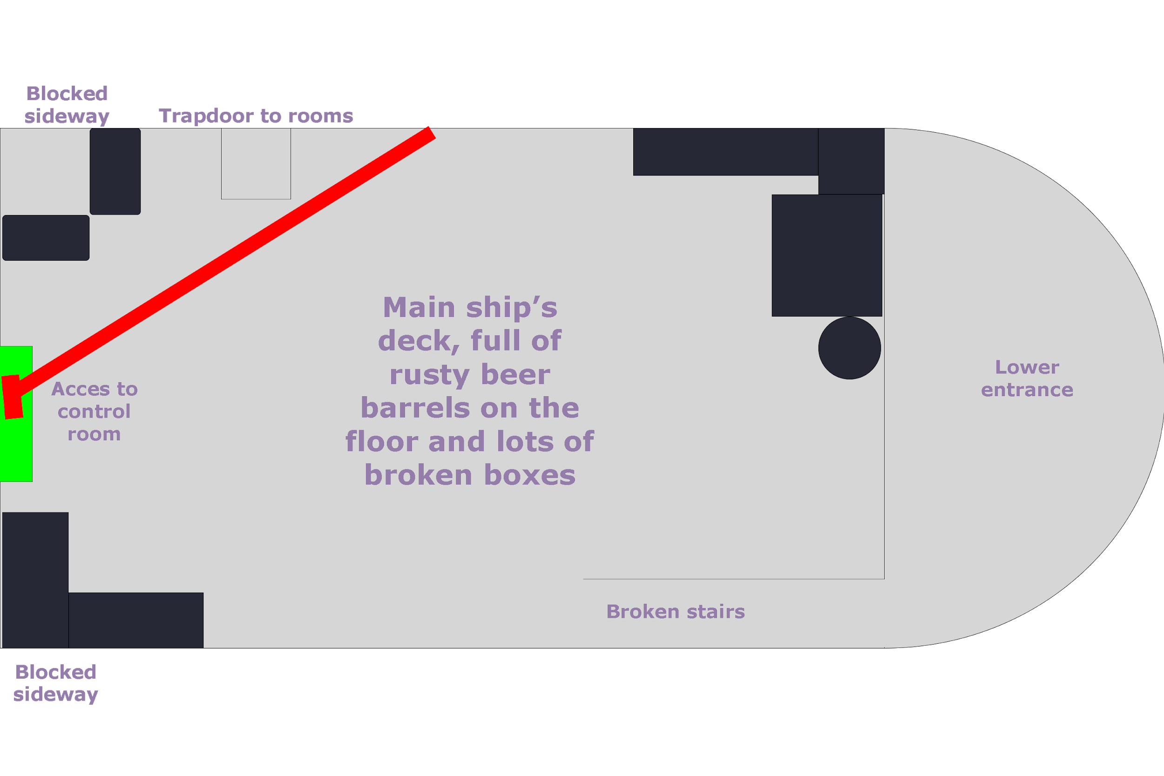

## Scene 3.2 - Rusty Ship: Command Room

Once inside of the "command room", the player may interact with the old captain to trigger a cutscene where he will be wounded by a beer bottle.

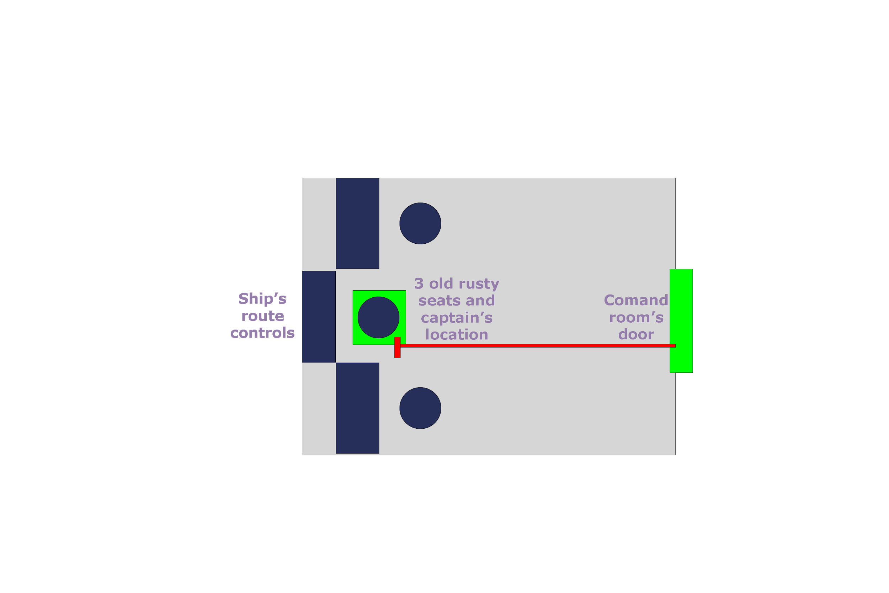

## Scene 4 - Cantina: Fuel Station

The player awakes inside the "command room" and exits the ship to find themselves on a small asteroid with a gas station and a bar, the player cannot fall off the scenery, instead, they have to interact with the "bar's entrance" to enter the bar.

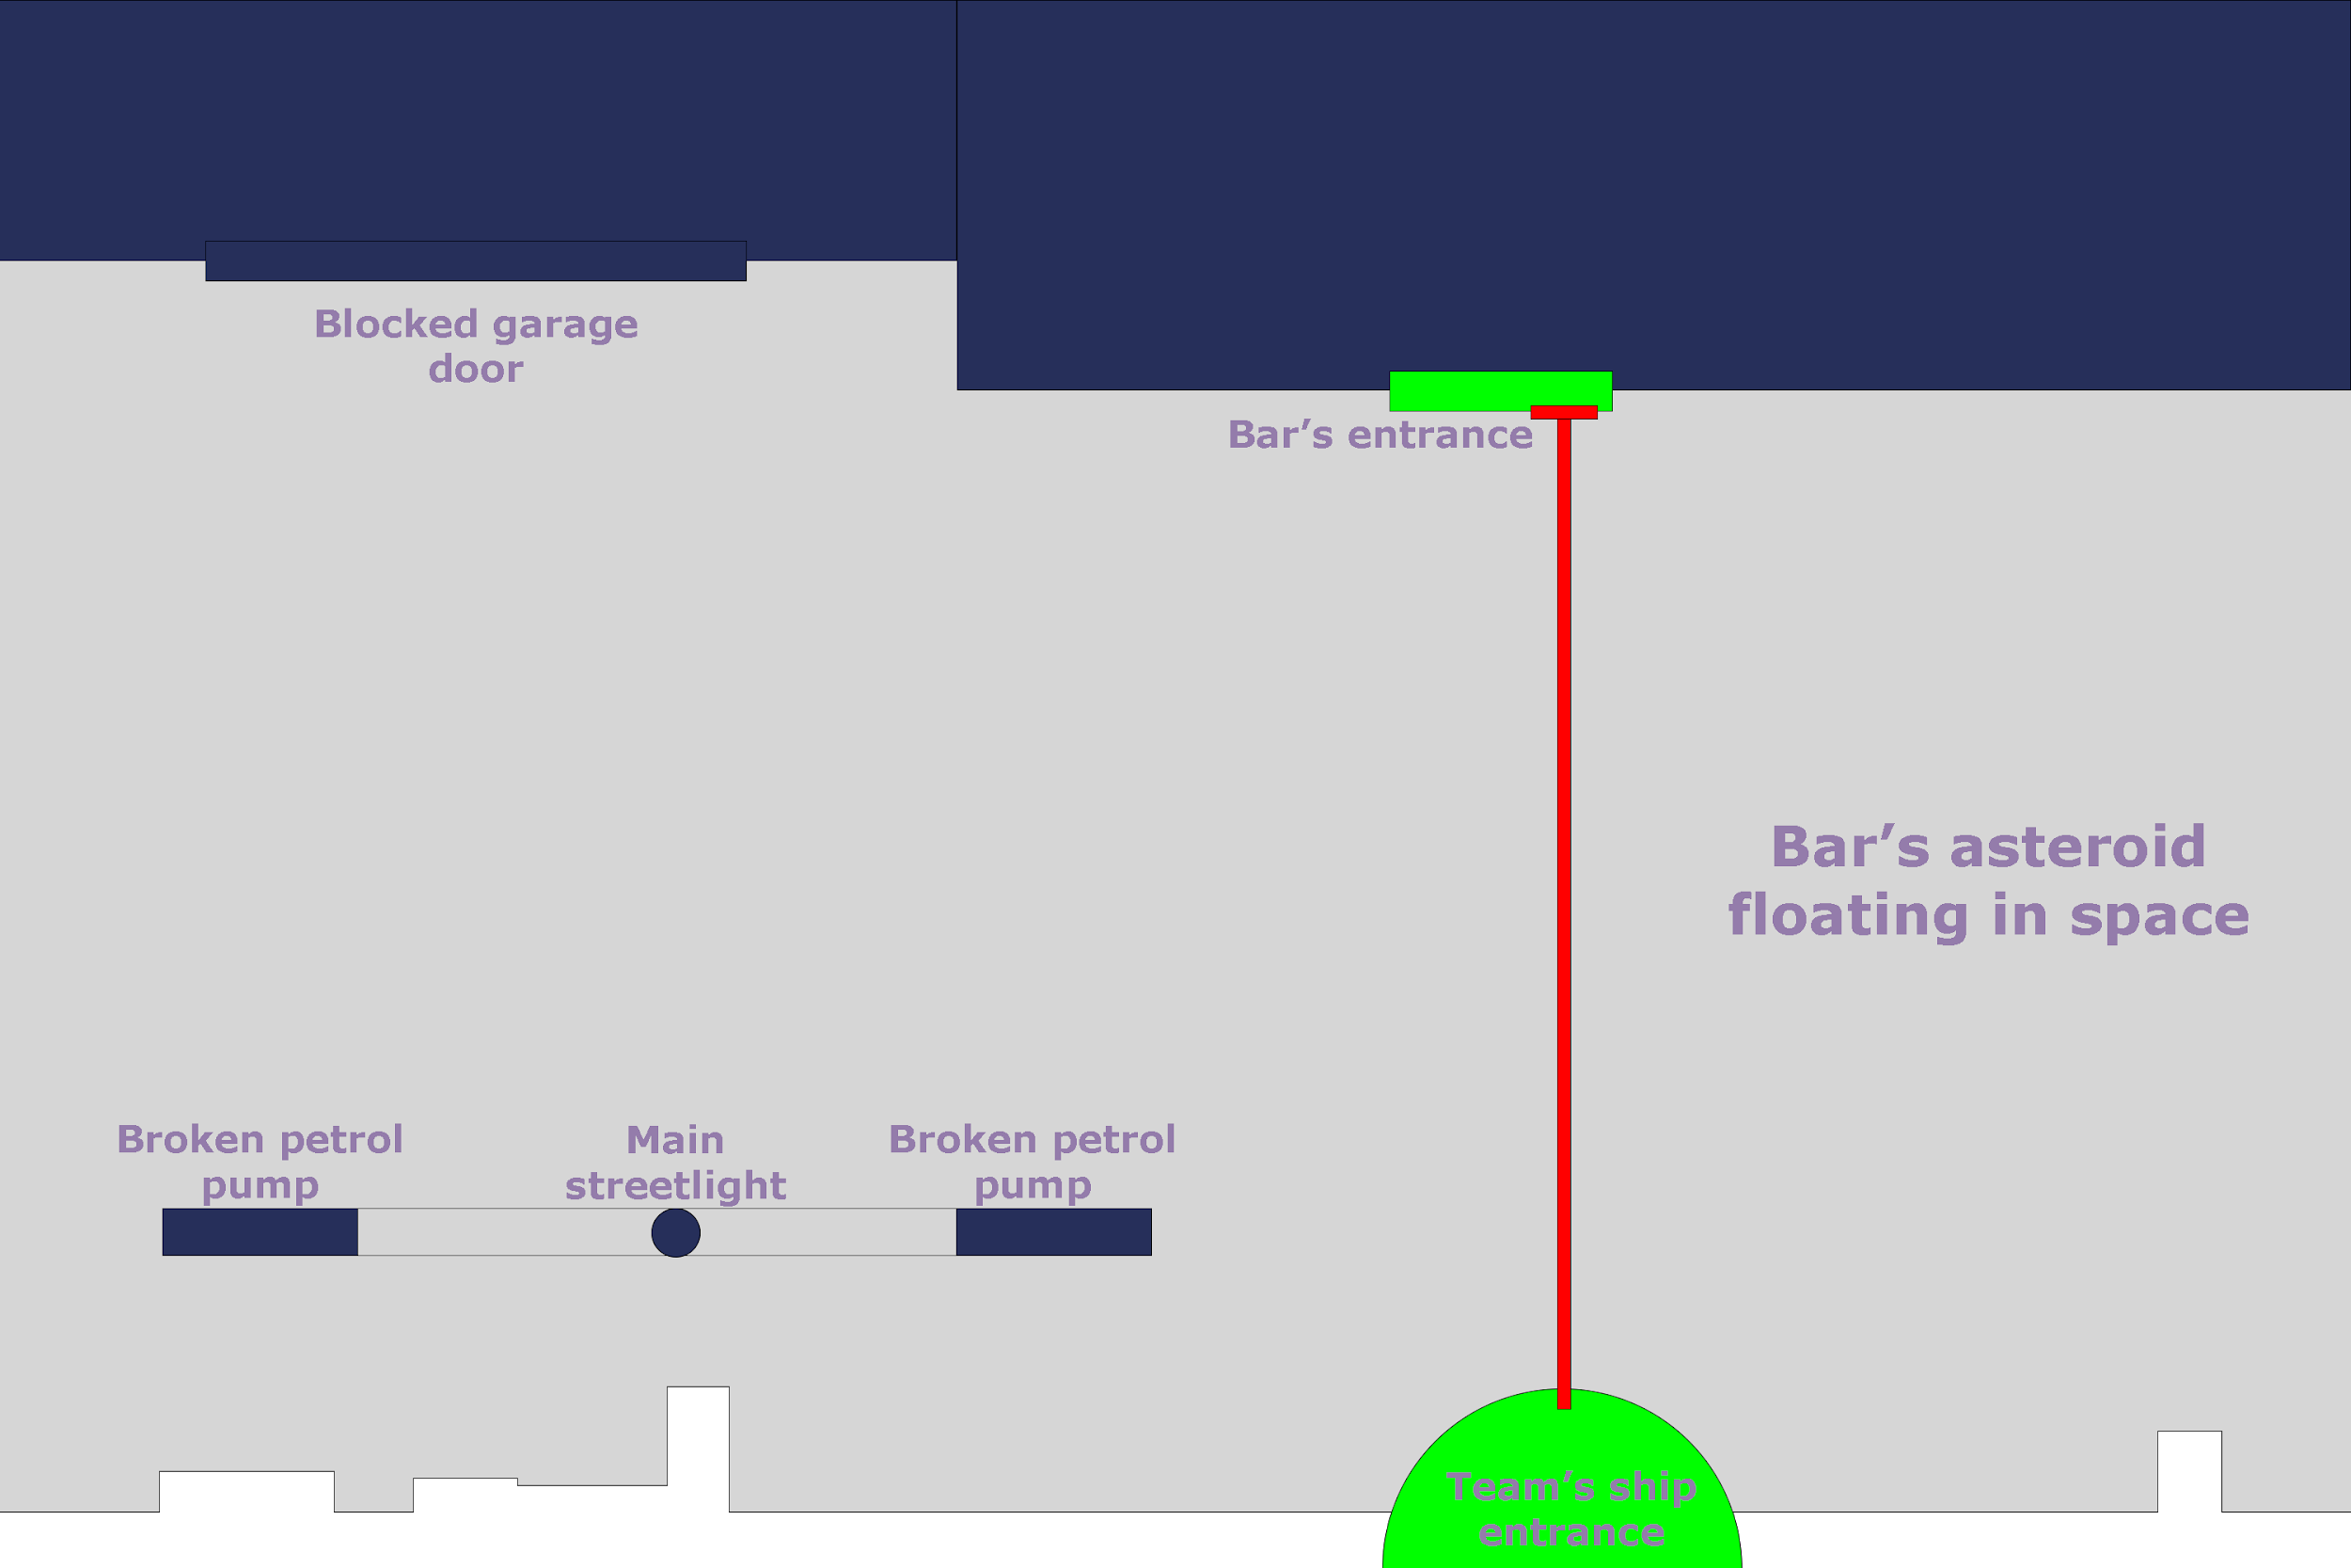

## Scene 5 - Cantina: Inside

Once inside the bar, the player gets called to the "bartender's location". After a talk, the player sees the old captain and his friend drinking in the "captain's drunk friend location", where the player will receive his main quest, after completing it and returning to the bar the bartender will offer a job for the main character. Some tables and chairs full of drunk people decorate the scene as well as the bar full of beer and wine bottles and there's a blocked kitchen door too.

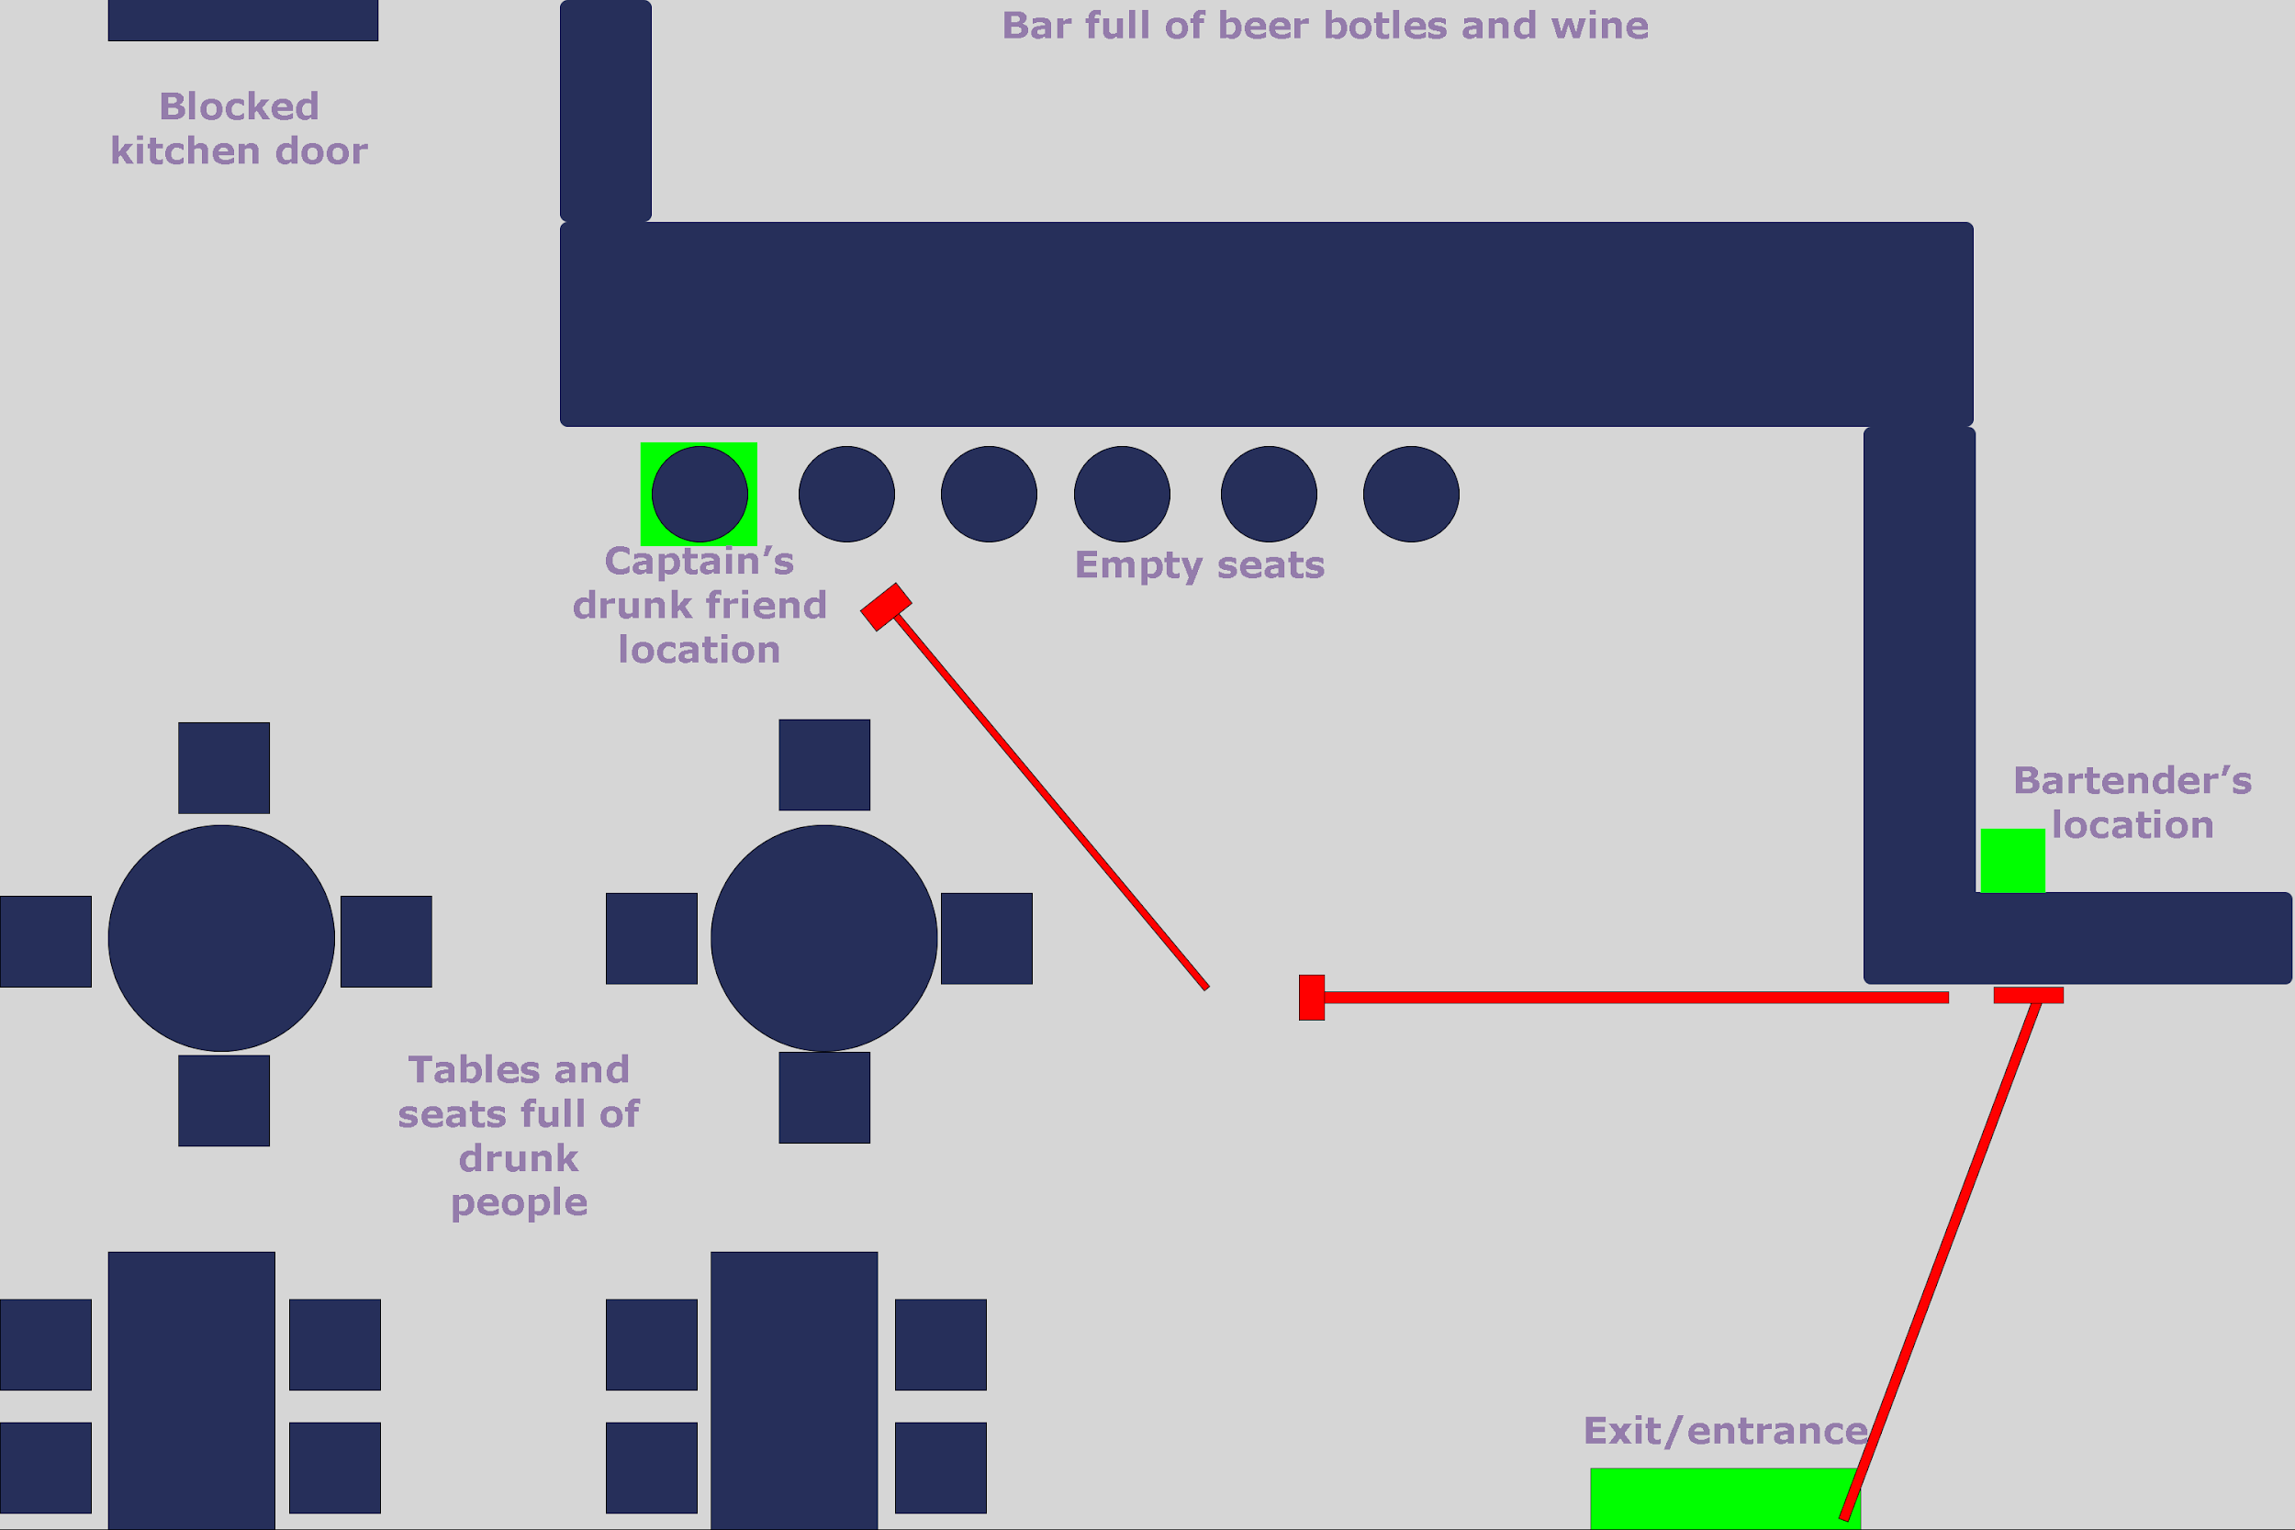

## Scene 6 - General Map

Upon leaving through the "bar's exit" and "team's ship entrance" seen in previous scenes the player will find himself at the main star map, starting from the "bar's location" the player must find the "landing zone" in the "abandoned planet location" going through some "asteroid fields orbiting the abandoned planet" and "space junk", if the player were to explore around this giant map he can find the "luxurious docks" in the upper right as well as some "spaceships passing by" in the upper left section of the map thus blocking his way into the "outer space non accessible regions", this regions can be found in all directions blocking the player from going to far away from his main objective.

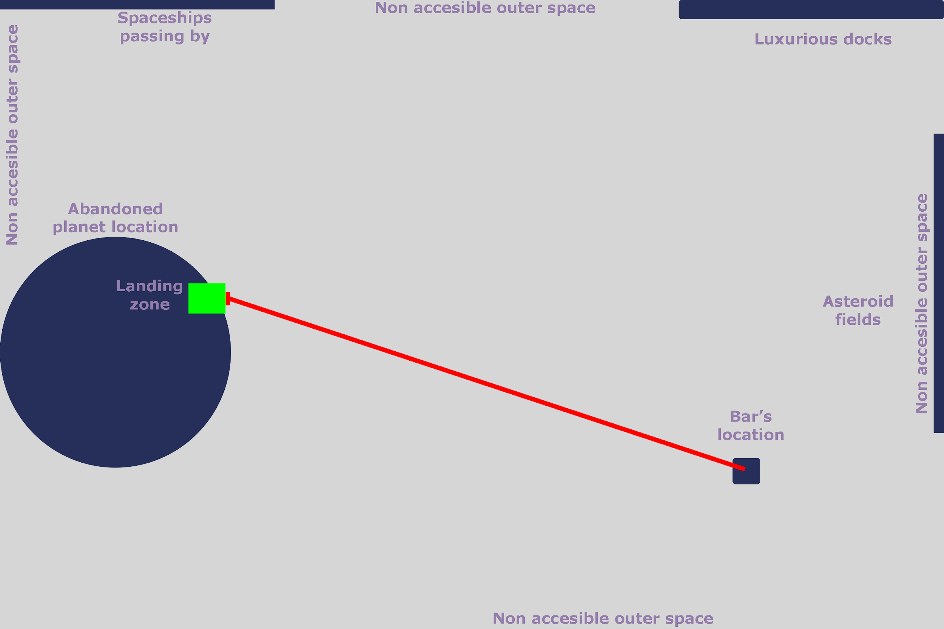

## Scene 7 - Dungeon: Entrance

The moment the player reaches the planet, he must enter the dungeon straight ahead.

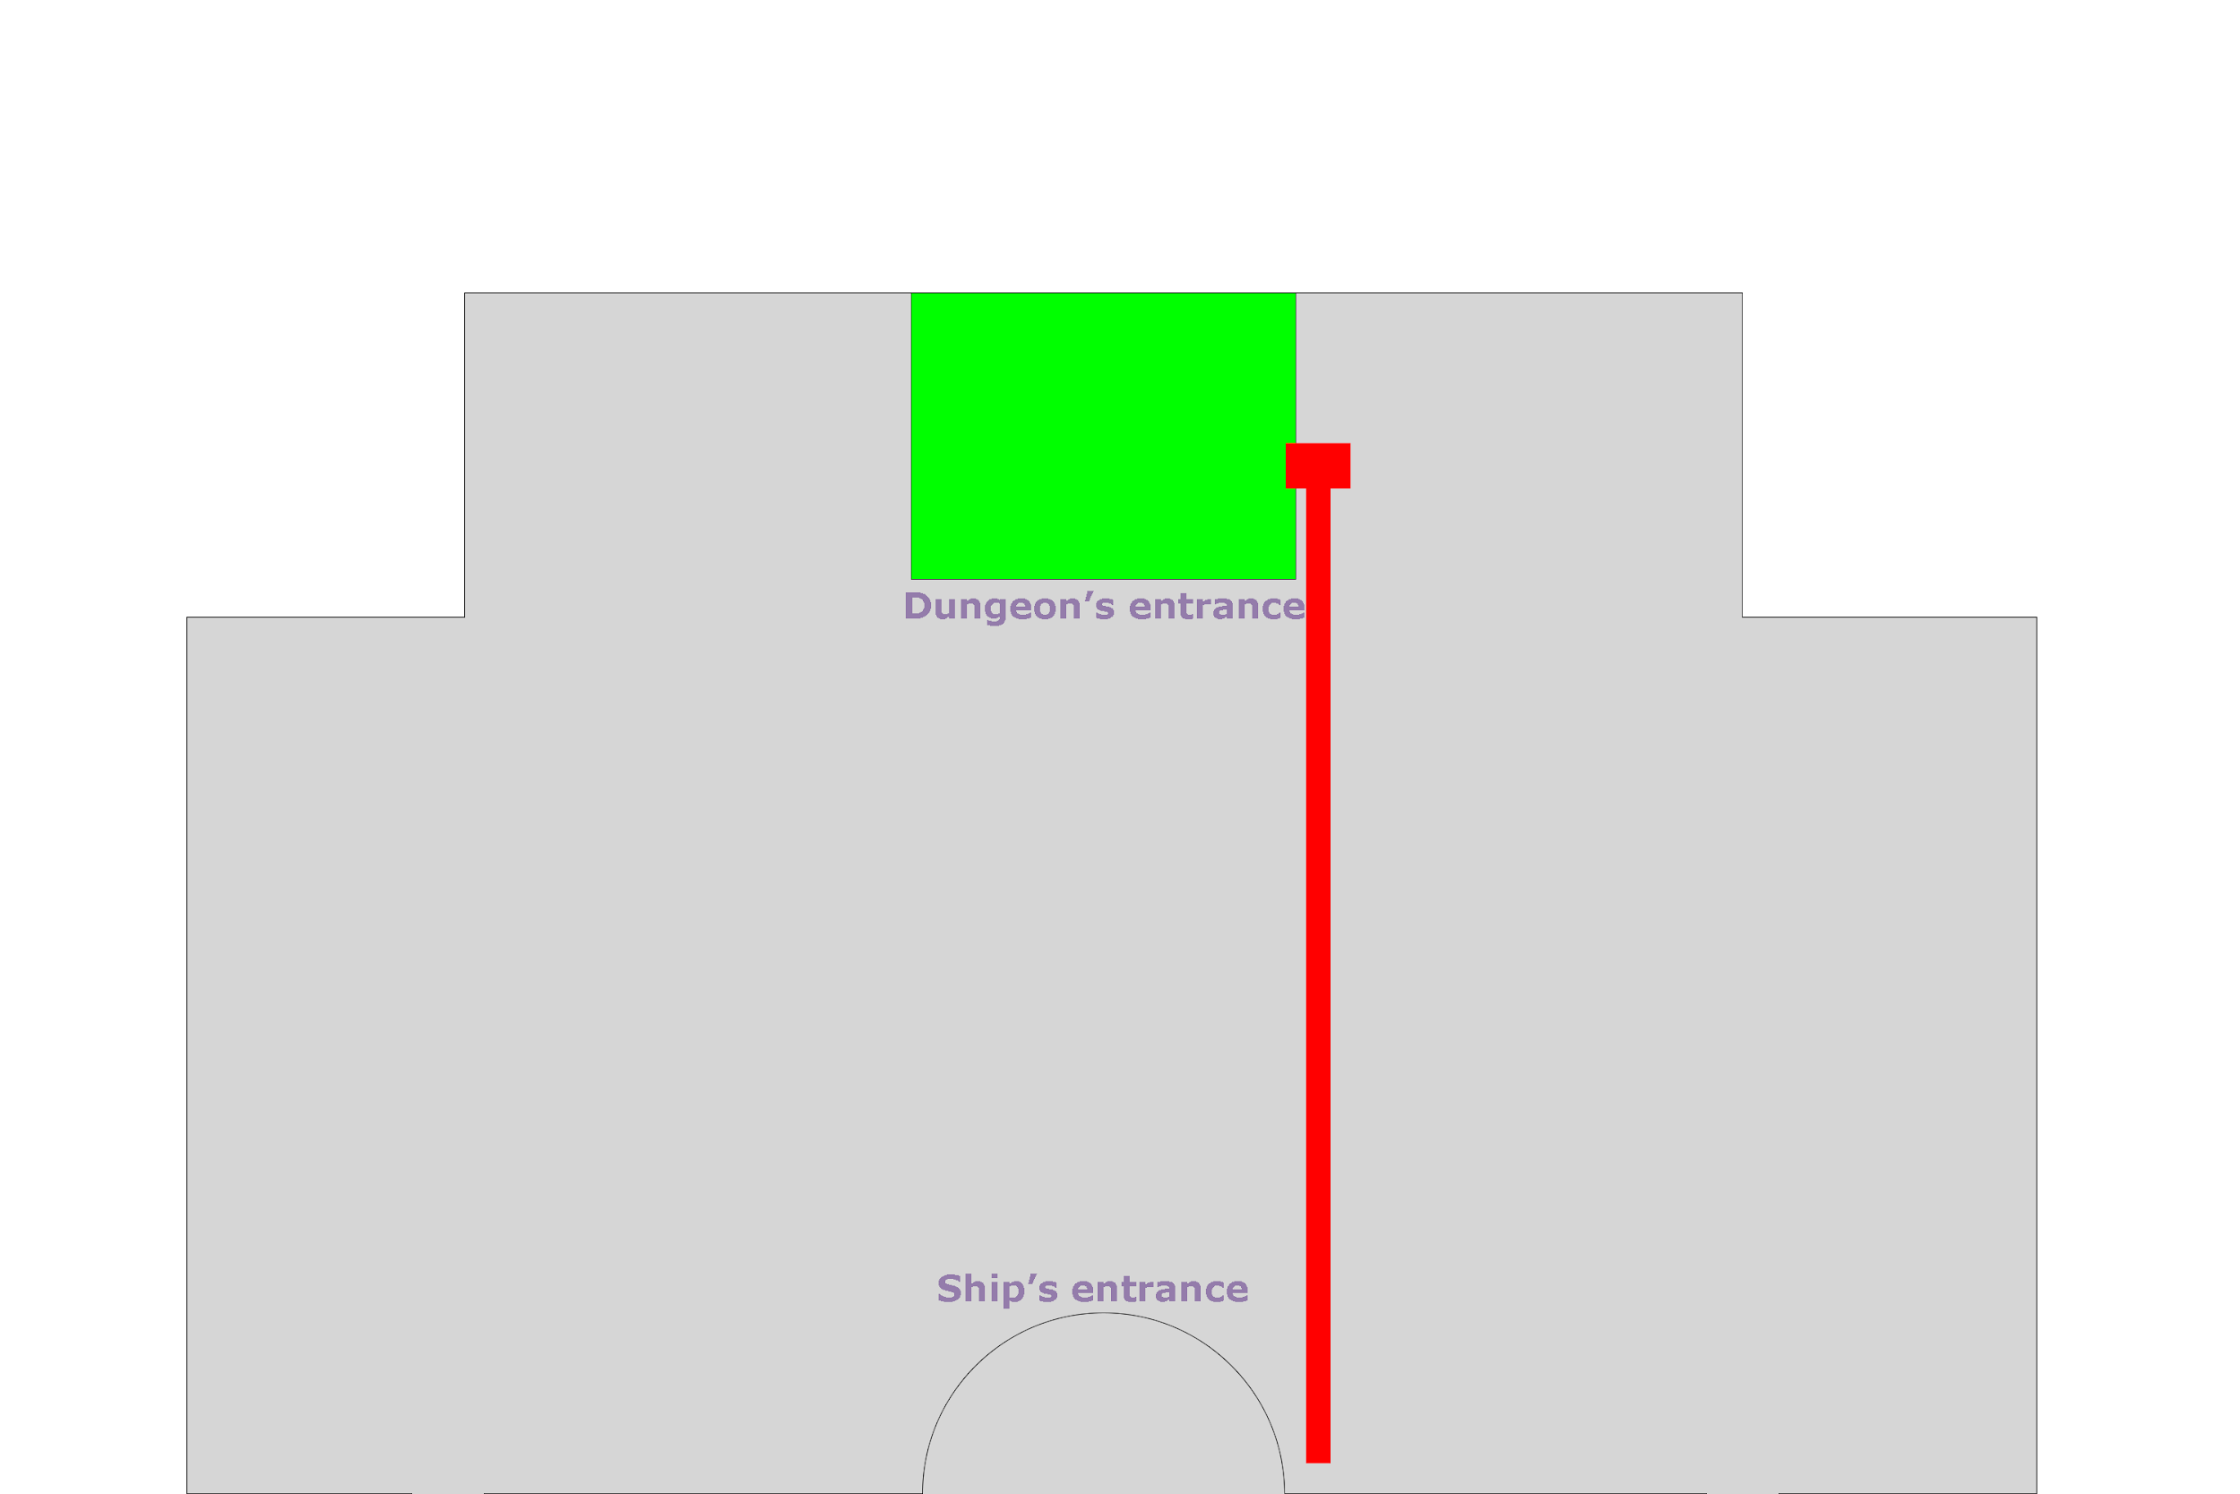

## Scene 8.1 - Dungeon: Level 1

Once inside the dungeon, the player must find out how to open the main 2 doors, the first door opens upon a sequence of lever activations in the same floor, upon activation of each lever an encounter is triggered with 3 enemies ,the sequence can be guessed from an interactable in the same room as the ladder to the second floor. For the second door the player must repeat the sequence but this time he has to move to the second floor and draw the figures with lever activations in the same order as he did for the first door.

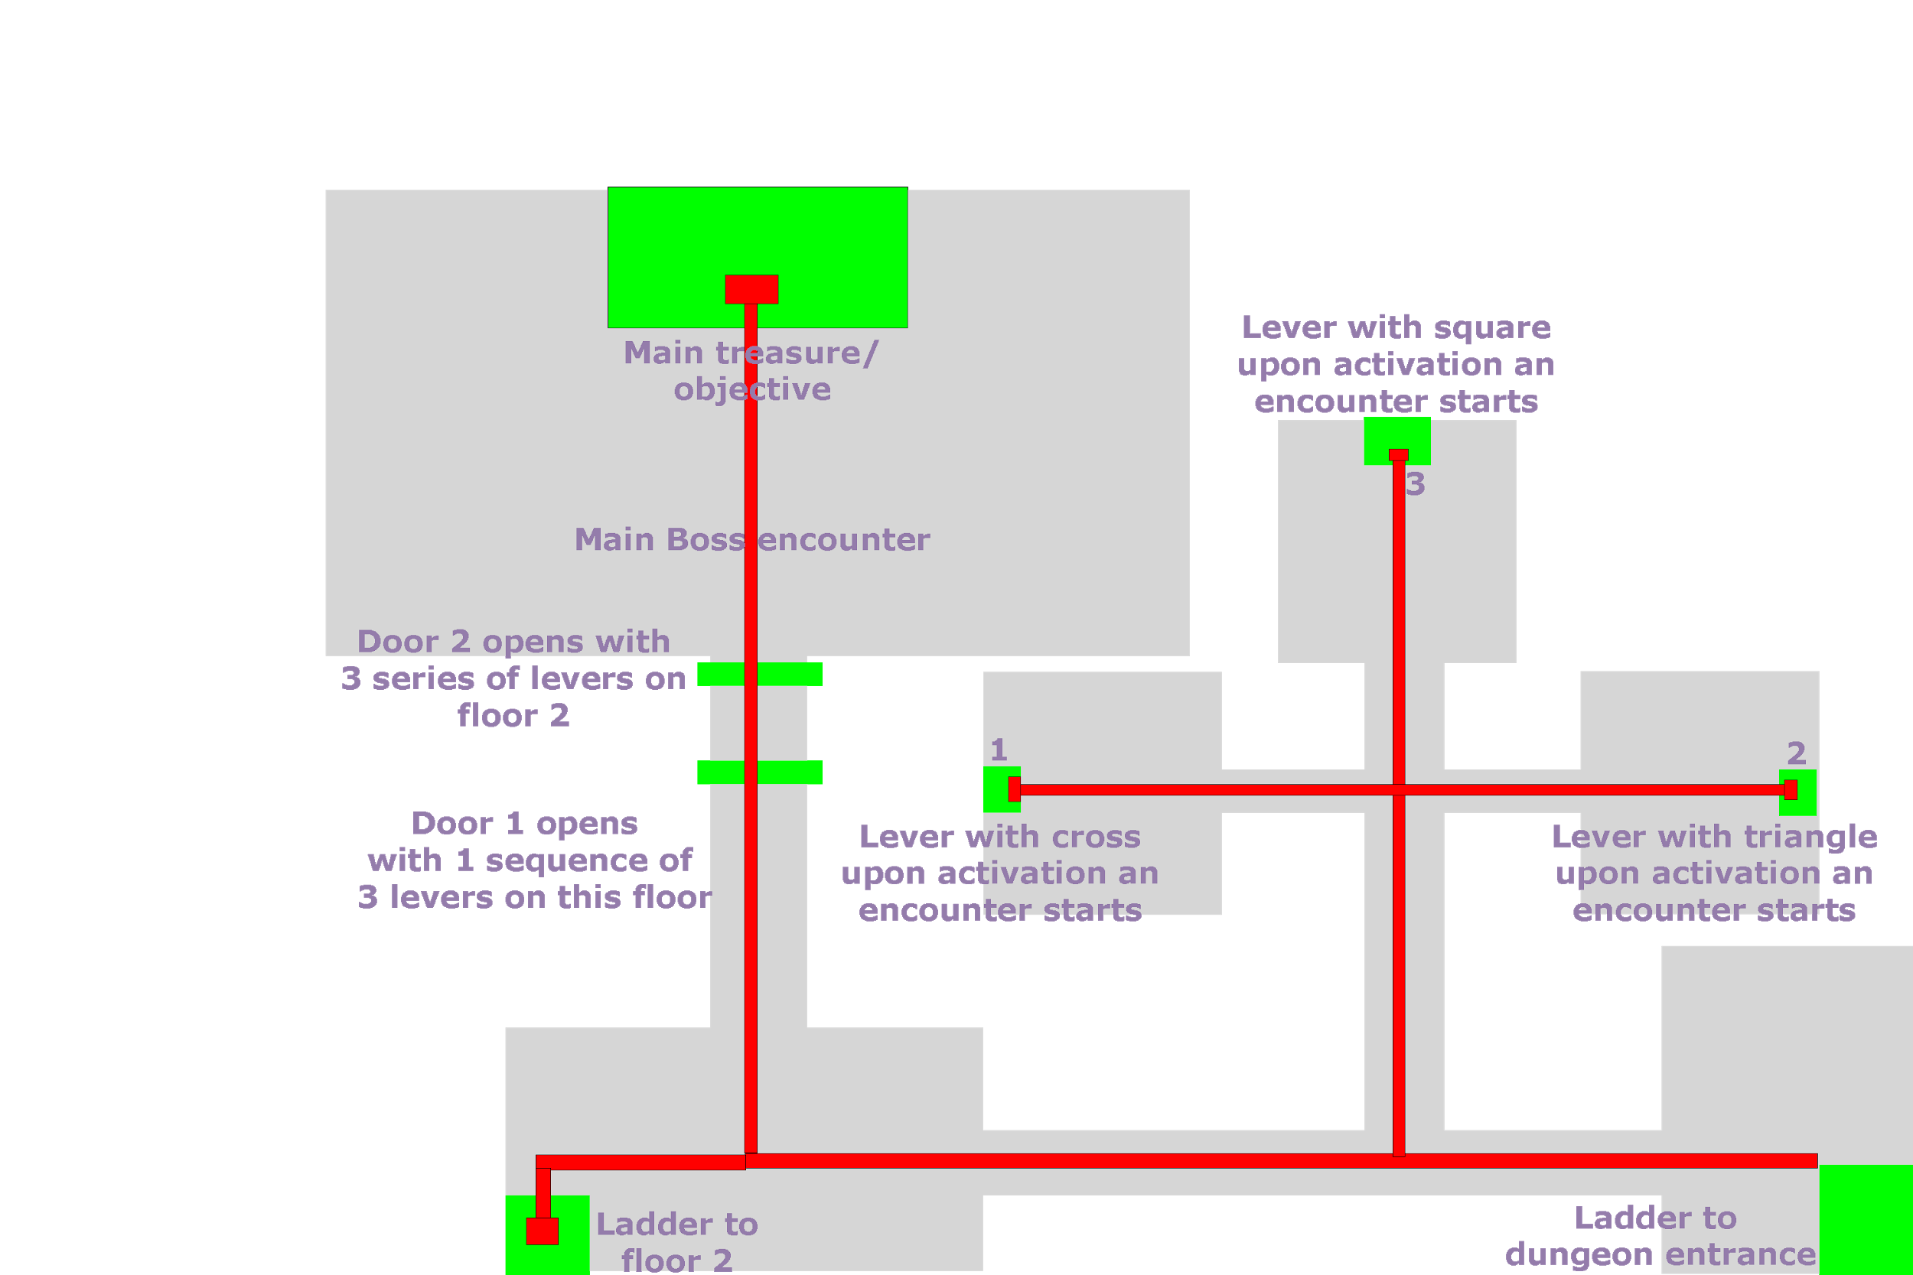

## Scene 8.2 - Dungeon: Level 2

Upon getting to the second floor, a miniboss encounter triggers with a horde of 5 enemies. In this floor, the player must draw the figures used to open the first door in the same order by activating a series of levers.

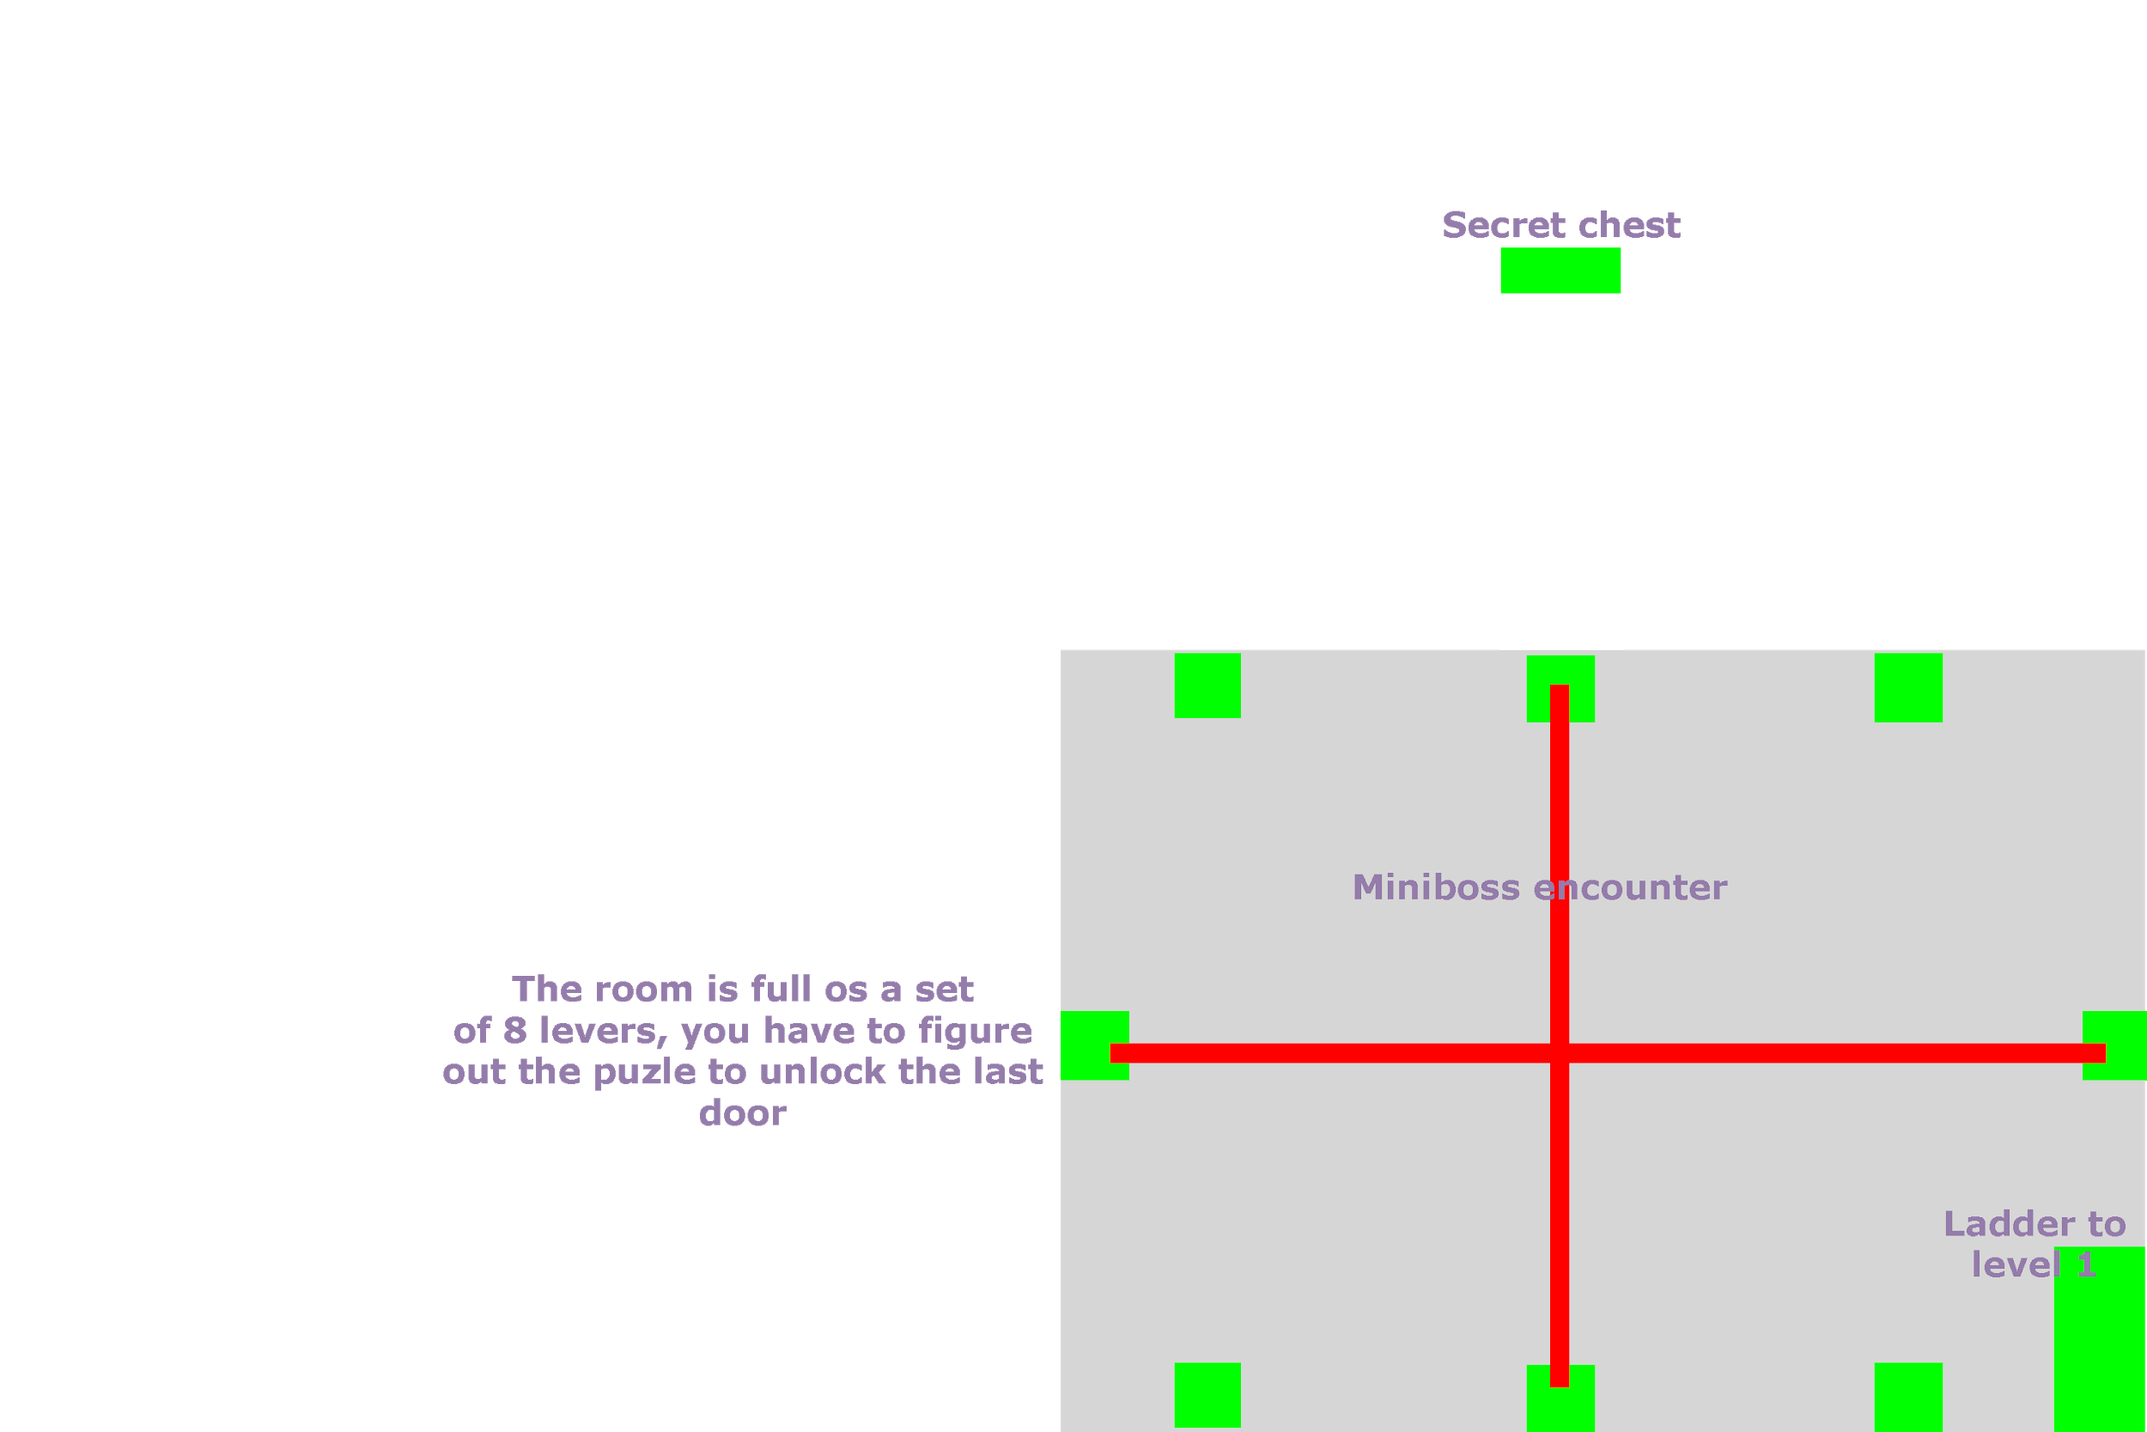

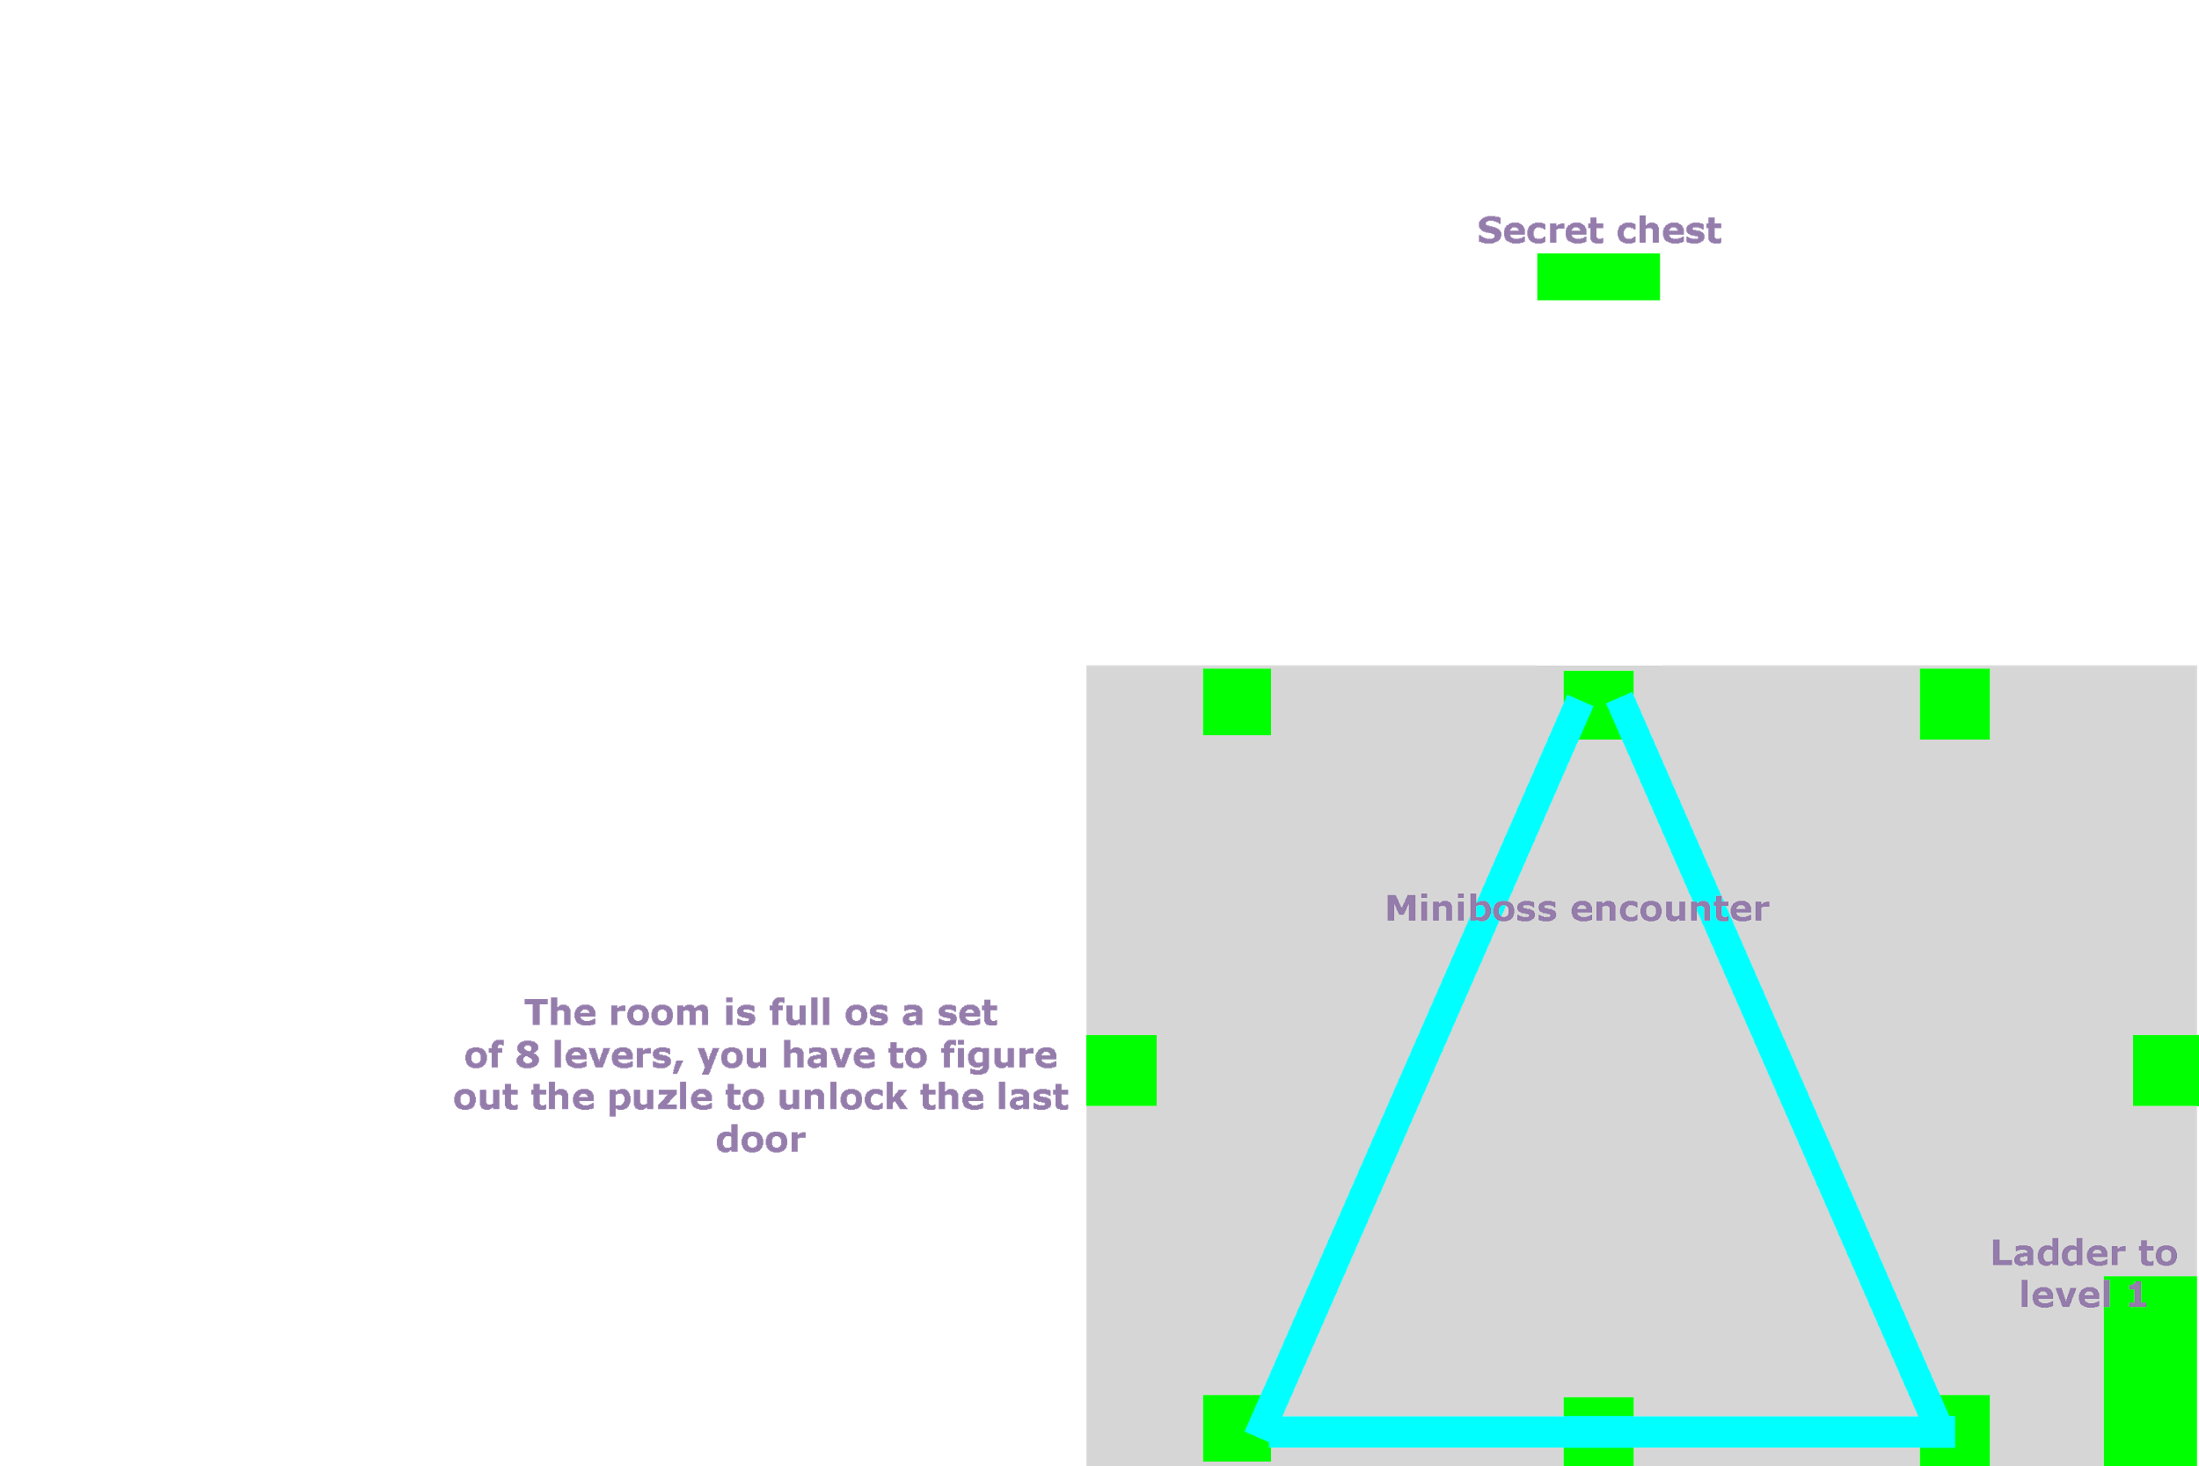

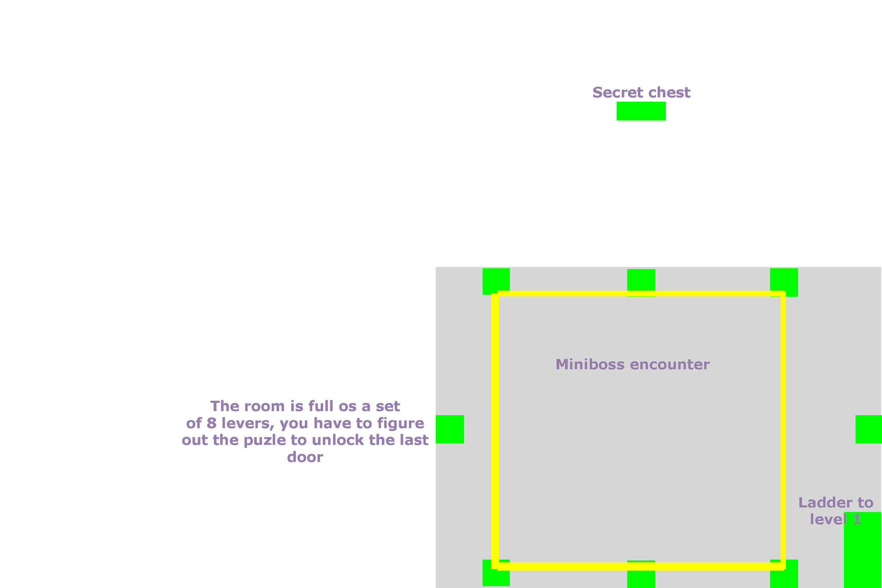

A secret door can be unlocked if the player interacts with the levers to form a star shape and if all the previous sequences have been completed.

